

"Practice the Unseen:
Menstrual Art as a Tool for Shifting Stigma"
Faculty of Literature and Philosophy
Department of SARAS (History, Anthropology, Religions, Art, Visual and Performing Arts)

REZVAN ZAREI JALALABADI
Matricola 2049240

Supervisor: Leonardo Campagna
Co supervisor: Romana Ando

A.A 2025-2026

Acknowledgements
I would like to express my sincere gratitude to my supervisor for their guidance, intellectual generosity, and critical insight throughout the development of this thesis. Their support has been invaluable in shaping both the theoretical framework and the articulation of my practice-based research.
I am also grateful to my second reader for their thoughtful feedback and engagement with the work. Their perspectives contributed meaningfully to the refinement of this research.
My thanks extend to the artists, scholars, and activists whose work informed and inspired this study, as well as to the friends and peers who offered dialogue, support, and reflection during the research and creative process.
Finally, I acknowledge my own body as a site of knowledge, endurance, and inquiry. This thesis would not exist without the lived, cyclical experience that it seeks to examine, record, and reclaim.

Abstract
Menstruation is a universal biological process that remains culturally stigmatized, rendered invisible through practices of concealment, sanitization, and silence. This thesis examines how menstrual art and media function as forms of public pedagogy, challenging dominant narratives that frame menstruation as shameful, polluting, or inappropriate for public representation. Drawing on feminist theory, art history, and media studies, the research traces a trajectory from early feminist interventions in the 1970s to contemporary artistic, televisual, and digital practices that insist on menstrual visibility.
Through analysis of archival practices, performance art, mainstream media representations, and social media activism, the thesis argues that making menstruation visible disrupts mechanisms of stigma, gendered bodily regulation, and patriarchal control. Key theoretical frameworks—including Kristeva’s concept of abjection, Douglas’s theory of purity and pollution, Butler’s performativity, and Goffman’s stigma theory—are employed to understand why menstrual blood provokes discomfort and how artists strategically mobilize this discomfort as critique.
The final chapter adopts a practice-as-research methodology, situating the author’s own artworks within this lineage of menstrual visibility. Through visual analysis and reflexive audience response, the creative works demonstrate how menstrual materials operate as archives of bodily time, vulnerability, and resistance. The thesis concludes that menstrual art not only challenges aesthetic norms but also produces cultural knowledge, offering new possibilities for agency, embodiment, and collective reimagining of the menstruating body. By reclaiming blood, stains, and duration as legitimate subjects of art and discourse, this research contributes to feminist scholarship that seeks to dismantle menstrual stigma and expand the boundaries of what can be seen, shown, and understood.

Table of contents

- Introduction………………………………………………………………………………..1
  - Type of thesis………………………….………………………………………..........3
  - Presentation of the Topic……...……………….……………………………..............3
  - Research Question and subjective…………………………………………………...4
  - Thesis statement………………………………………………………………..........4
  - Methodology………………………………………………………………………..5
- Theoretical Foundations: Stigma, Abjection, and Queer Reframing……………….……….6
  - Gendered Otherness and Embodiment…………………………………………….6
  - Stigma, Concealment, and Social Regulation……………………………………….8
  - Purity, Pollution, and the Regulation of Menstrual Bodies………………………….9
  - Abjection and Bodily Boundary-Making…………….……………………………...11
  - Performativity, Temporality, and Queer Perspectives on Menstruation…………….13
  - Digital Activism and Contemporary Menstrual Discourse………………………….15
- Technologies of Concealment: Fashion, Hygiene, and Menstrual Capitalism…….………...17
  - Fashion & Containment: Menstrual Concealment and the Gendered Body Project……………………………………………………………………………..18
  - Suppression Technologies: The Intersection of Medical Innovation, Gendered Power, and Consumerism ………………………………………………………….……...20
  - Menstrual Capitalism & Global Inequalities………………………………………..22
  - Queering Menstruation and Menstrual Products…………………………………...24
- Menstrual Art and Media as Public Pedagogy………………………………………............28
  - From Private to Public: Making Menstruation Visible Through Art………………..28
  - Archiving the Menstrual Body: Documenting the Cycle in Art……………..………31
  - Performing Menstruation: The Body as Spectacle………………………….………33
  - Mainstreaming Menstruation: From TV Screens to Social Media Activism………. . 37
- Art as Practice: Creative Work and Reflexive Analysis…………………………….………40
  - “The Fear of a Defined ‘I’”: The Female Body Between Possibility and Constraint…………………………………………………………………………40
  - “Between Bliss and Blood”: Pleasure, Duration, and the Visibility of the Menstruating Body………………………………………………………….........43
  - “The Body as Archive” …………………………………………………………48
- Conclusion……………………………………………………………………………..53
6.2 Future Perspectives………………………………………………………………….55
References……………………...……………………………………………………………57

1. Introduction
Menstruation is a cyclical physiological process essential to human reproduction, yet few bodily functions have been as culturally misunderstood, silenced, and stigmatized. Across geographical regions and historical periods, menstruation has been positioned as something to hide, control, or purify, reflecting deeply rooted social anxieties about bodily leakage, gender norms, and the boundaries between the clean and the unclean. Anthropologist Mary Douglas (1966) famously argued that notions of purity and pollution are not inherent qualities but cultural mechanisms that maintain social order; bodily substances become “matter out of place” (p. 44) when they violate symbolic boundaries. In this framework, menstrual blood is not shameful because of any objective impurity, but because it disrupts social expectations of bodily containment and threatens the idealized, orderly image of femininity that many cultures demand.
From early adolescence, menstruators learn to manage their bodies through concealment. This internalization of stigma is reinforced through socialization, familial silence, media censorship, and the design of menstrual products themselves. Feminist theorist Simone de Beauvoir (1949/2011) observed that women are taught to experience their bodies as “a burden” (p. 350), particularly when they exhibit cyclical changes that deviate from male bodily norms. Such early conditioning produces hypervigilance: fear of leaking, fear of staining clothes, fear of smelling, fear of being seen. Erving Goffman’s (1963) concept of the “discreditable” stigma—attributes that must be hidden to avoid social penalties—aptly describes menstruation’s precarious cultural status. Menstruators are routinely tasked with managing information about their bodies, regulating visibility, and preemptively preventing “embarrassment,” all of which contribute to psychological strain and bodily alienation.
My own early encounter with menstrual stigma reflects these wider dynamics. At twelve years old, seated in an all-girls school classroom, I felt a dampness beneath me that I initially attributed to sweat. Only upon standing did I realize the chair was stained with blood. The intensity of the shame that followed—the desire to disappear, to erase myself rather than allow others to witness my body in its unfiltered state—was not innate but learned. This moment, like so many similar experiences recounted by menstruators globally (Bobel, 2020), demonstrates how menstruation becomes a site where vulnerability, social surveillance, and bodily normativity intersect.
Such anxieties are exacerbated by cultural environments that demand menstrual invisibility. Advertisements substitute blue liquids for actual blood; tampon commercials emphasize “discreetness”; films often avoid menstruation entirely or depict it as comedic grotesque (Johnston-Robledo & Chrisler, 2020). In many religious traditions, menstruation is coded as dangerous, impure, or socially disruptive (Ahmed, 1992). Even in putatively modern societies, menstrual health is underfunded, menstrual products are taxed as luxury goods, and menstruation remains absent from public discourse (Weiss-Wolf, 2017). These silences reinforce a biopolitical regime in which menstruating bodies are regulated through shame, control, and cultural suppression.
It is against this backdrop of concealment that menstrual art offers a radically different visual and conceptual vocabulary. Beginning in the 1970s with feminist artists such as Judy Chicago, Carolee Schneemann, and Ana Mendieta, menstrual art emerged as a deliberate rupture in the sanitized narratives surrounding womanhood and bodily purity. By making menstruation visible—sometimes viscerally so—artists intervene in the cultural scripts that govern gendered embodiment. Kristeva’s (1982) notion of the abject is particularly relevant: menstrual blood, as a boundary-crossing substance, evokes discomfort because it unsettles the distinction between the self and the other, the inside and the outside, the clean and the unclean. Menstrual art thus becomes an encounter with the abject, but also a reclaiming of that abjection as a site of agency and aesthetic power.
Contemporary scholarship further expands the meaning of menstrual visibility. Emily Martin’s (1987) seminal work The Woman in the Body demonstrates how biomedical narratives frame menstruation as failure or loss, reinforcing patriarchal ideologies that pathologize female physiology. More recent studies in the Palgrave Handbook of Critical Menstruation Studies (Bobel et al., 2020) highlight how menstruation intersects with race, class, disability, and gender identity, emphasizing that menstrual stigma is neither universal nor evenly distributed. Queer and trans scholars, such as Frank (2020), argue that menstrual discourse must move beyond cisnormative assumptions, recognizing that many nonbinary and trans individuals also menstruate and experience heightened stigma due to gendered expectations of silence and erasure.
Menstrual art intervenes precisely at this intersection of personal experience and sociocultural politics. For the menstruator–artist, using menstrual blood or representing the bleeding body can be an act of confronting internalized shame—what Fahs (2016) describes as “embodied resistance” (p. 112). For audiences, such works can provoke reflection, discomfort, empathy, or recognition, challenging cultural scripts that separate the “acceptable” body from the leaking, bleeding, uncontrollable body. As Butler (1988) argues, gender is constituted through repetition; menstrual art disrupts these repetitions by exposing the instability of gender norms and revealing the material realities that dominant culture attempts to hide.
This thesis examines how menstrual art—across performance, photography, bodily documentation, and digital activism—functions as a transformative practice capable of reshaping public attitudes toward menstruation. It explores how menstrual visibility destabilizes stigma, how menstrual bodies in art challenge entrenched ideologies of purity and propriety, and how creative practices can support broader cultural shifts toward openness, acceptance, and bodily autonomy. By situating menstrual art within theoretical frameworks from feminist philosophy, body studies, and visual culture, this research argues that visibility itself becomes a radical tool: one that reveals, resists, and reimagines the meanings ascribed to menstruating bodies.

1.1 Type of thesis
Project/Creative art work

1.2 Presentation of the Topic
Menstruation occupies a complex and often contradictory space in contemporary culture: biologically routine yet socially marginalized, physically visible yet culturally hidden. Despite its universality, menstruation is rarely represented authentically in visual culture, art, or media, often reduced to symbols, sanitized imagery, or humor. This absence reflects broader societal discomfort with the female body and its functions, revealing how cultural norms dictate what can be seen, spoken, and acknowledged.
This thesis explores menstruation as both material and concept, positioning it as a site where embodiment, social expectation, and cultural regulation intersect. Artistic practice offers a critical method to examine these intersections: through painting, embroidery, performance, photography, and installation, menstrual materiality can be transformed from a private, disposable process into a public, visible, and politically resonant form. In doing so, menstrual art challenges conventions of concealment, questions stigmatizing narratives, and reframes the body as an agent of knowledge, resistance, and creativity.
The research examines how menstruation functions not merely as a biological phenomenon but as a cultural and political category. By engaging directly with the materials, traces, and rhythms of the menstrual cycle, the artworks studied in this thesis make visible what is systematically hidden, offering both personal reflection and collective critique. The study emphasizes the ways in which menstrual visibility—through creative practice—can disrupt ingrained stigma, generate dialogue, and expand understandings of bodily experience across gendered, cultural, and social contexts.
Ultimately, this research situates menstruation at the intersection of art, theory, and activism. It proposes that by engaging with menstrual bodies and materials in visual and performative practice, artists can challenge established norms, reveal the mechanisms of stigma, and open space for more inclusive and politically attentive representations of the body.

1.3 Research Question and subjectives
This research is guided by two central questions that aim to examine the relationship between menstrual experience, cultural stigma, and artistic practice:
- How can menstrual art challenge historical and contemporary stigma surrounding menstruation in visual culture?
- In what ways can creative practices—such as performance, photography, and material engagement—reframe menstruation as a site of agency, visibility, and political intervention?
The primary objectives of this thesis are:
- To explore and articulate the cultural, social, and political mechanisms that regulate and stigmatize menstruation, drawing on feminist, queer, and trans scholarship.
- To analyse how menstruation is represented—or erased—in contemporary visual culture, including advertising, media, and art practices.
- To document and reflect upon my own creative practice, investigating how menstrual materials, blood, and bodily traces can function as expressive media.
- To contribute to interdisciplinary discourse bridging art practice, feminist theory, and cultural studies, offering insights into how embodied experience can inform critical and activist creative work.
By addressing these questions and objectives, this thesis seeks to demonstrate the potential of menstrual art to both critique and transform societal perceptions, positioning menstruation not as a source of shame but as a meaningful, visible, and politically significant aspect of human experience.

1.4 Thesis statement
Menstruators’ art that exposes the hidden realities of bleeding stands as a powerful act of resistance against stigma and silence. This thesis argues that such creative practices not only educate society but also actively dismantle menstrual taboos, opening space for honest dialogue and social change.

1.5 Methodology
This thesis adopts a qualitative, feminist, and theoretically driven methodology to examine how menstrual art challenges sociocultural stigma and reshapes public perceptions of menstruation. Because the research concerns symbolic meaning, embodied experience, and visual representation, interpretive qualitative methods are the most suitable. Grounded in feminist epistemology, this approach understands knowledge as situated and shaped by power, particularly concerning gendered bodies and the cultural regulation of menstruation (Haraway, 1988; Harding, 1991). Menstruation has historically been interpreted through patriarchal, medical, and religious discourses, and a feminist methodology enables a critical examination of how these structures shape both experience and representation.
The material studied in this thesis consists of menstrual artworks, media representations, and relevant scholarship. The art corpus includes performance, photography, painting, and documentation from artists such as Judy Chicago, Carolee Schneemann, Shigeko Kubota, Ana Mendieta, Judy Clark, Carina Úbeda, Vanessa Tiegs, and Jasmine Alicia Carter. These works are analyzed not only for their visual or material qualities but also for their political and symbolic subversion of menstrual stigma. Mainstream media representations—from films like Carrie and Turning Red to television scenes such as Charlotte and Lily’s menstrual visibility in And Just Like That…, as well as digital activism including Rupi Kaur’s censored Instagram image—provide additional insight into contemporary negotiations of menstrual taboo and censorship. These artistic and media sources are interpreted alongside a wide literature from feminist theory, queer theory, anthropology, and critical menstruation studies, including foundational texts by Douglas (1966), Kristeva (1982), Goffman (1963), Butler (1988), Martin (1987), and contemporary work in the Palgrave Handbook of Critical Menstruation Studies (Bobel et al., 2020).
The analytic strategy combines close visual interpretation with theoretical application. The research draws on Julia Kristeva’s notion of abjection to understand why menstrual blood provokes cultural anxiety, and on Mary Douglas’s analysis of purity and pollution to examine how menstruation becomes symbolically marked as disorder. Erving Goffman’s framework of stigma and information management illuminates the pressures placed on menstruators to conceal bodily evidence, while Judith Butler’s theory of performativity situates menstrual visibility as a potential disruption of normative femininity. Emily Martin’s critique of biomedical discourse and contemporary queer menstruation scholarship (Frank, 2020; Chrisler, 2020) help to contextualize menstrual art within broader political debates about gender, embodiment, and bodily autonomy.
Throughout the study, my position as a menstruator–researcher whose artistic work documents menstrual bleeding informs the methodological approach. This reflexive element follows feminist traditions that recognize the researcher’s embodied experience as epistemically valuable rather than neutral or external to the analysis. My work is not treated as empirical data but serves as a lens through which to understand vulnerability, visibility, and the reclamation of menstrual materiality.
Because this is an interpretive and theoretical project, it does not involve human subjects or empirical fieldwork. Instead, it focuses on analyzing cultural texts and artworks to uncover how menstrual visibility operates as a site of resistance. While the corpus primarily reflects Western and digitally mediated contexts—an unavoidable limitation—it nonetheless provides a robust foundation for examining how menstrual art intervenes in, critiques, and reimagines cultural narratives surrounding menstruation. This methodology therefore offers a rigorous and theoretically grounded framework for understanding menstrual art as a transformative practice that challenges stigma and makes possible new ways of seeing and experiencing the menstruating body.

2. Theoretical Foundations: Stigma, Abjection, and Queer Reframing
This chapter examines how menstruation has been theorized within feminist and queer scholarship, focusing on how bodily processes are regulated, stigmatized, and politicized. Drawing on classical feminist theory alongside more recent queer and trans perspectives, the chapter situates menstruation as a site of gendered governance and resistance. By tracing these theoretical frameworks, the chapter establishes the conceptual foundation for analyzing menstrual art as a form of embodied critique.

2.1 Gendered Otherness and Embodiment
In The Second Sex (1949), Simone de Beauvoir introduces the concept of woman as the "Other," positioning women in relation to men, who are considered the universal subject. She writes, "He is the Subject; he is the Absolute. She is the Other" (Beauvoir, 1953, p. 15). In this formulation, man is the normative subject of history and experience, while woman is defined only through her relation to him—an incomplete, secondary other. Beauvoir argues that man embodies freedom, transcendence, and agency, while woman is associated with immanence, reproduction, and the body. This creates a cultural hierarchy in which men are seen as independent subjects and women are relegated to the realm of the body, linked to the private and the domestic. Beauvoir stresses that this distinction is not biological but socially constructed. Woman is seen as imperfect, disruptive, and deficient in relation to men’s rational, transcendent role. Beauvoir writes, "The female is defined as a function of her organs: her uterus, her vagina, her breasts. She is born with them, but they become the symbols of her identity, and all she can do is to confirm this identity through marriage and motherhood" (Beauvoir, 1953, p. 259). Menstruation, therefore, is culturally silenced, becoming a taboo that signifies woman’s otherness in patriarchal society.
However, Beauvoir’s analysis remains limited by its focus on white, European women. Her framework does not account for the compounded oppression faced by women of color. Audre Lorde critiques this in Sister Outsider (1984), arguing that feminist thought must also address how race, class, and sexuality intersect in the experience of oppression. Lorde writes, "It is not our differences which separate women, but our reluctance to recognize those differences" (Lorde, 1984, p. 117). By ignoring these lived realities, feminist movements risk perpetuating the very systems of oppression they aim to challenge. For women of color, Otherness is compounded: they are not only excluded by men but also by mainstream feminist frameworks that center white, privileged experience. Lorde expands Beauvoir’s framework by urging feminists to center the lived realities of women of color and recognize the intersections of oppression. She writes, "Ignoring the differences of race between women and the implications of those differences presents the most serious threat to the mobilization of women’s joint power" (Lorde, 1984, p. 117). This call to acknowledge difference becomes a crucial principle in intersectional feminism, broadening the conversation to include the experiences of marginalized groups, and challenging dominant feminist discourses that exclude non-white, non-middle-class women.
Lorde’s critique also challenges the norms of white-dominated feminism by asserting that the master’s tools—the strategies used by the dominant group—cannot dismantle the master’s house. She argues, "For the master’s tools will never dismantle the master’s house" (Lorde, 1984, p. 112). This highlights the limitations of using traditional feminist frameworks to fight against patriarchy, as they often fail to recognize the complex intersections of race, class, and gender. Lorde calls for a more inclusive and intersectional feminism that recognizes difference and refuses silence in the face of oppression.
Lorde’s work is also vital in addressing the experiences of transgender men and non-binary menstruators. These individuals often experience alienation when menstruating, as menstruation does not fit within normative, cisgender frameworks of womanhood. The dissonance between their gender identity and the biological reality of menstruation can be alienating, highlighting the need for queer inclusion in feminist discussions about menstruation. Lorde’s critique of Otherness thus extends to include non-binary and transgender perspectives, urging that menstruation exists across diverse bodies and should be acknowledged and validated. As Lorde powerfully asserts, "Your silence will not protect you" (Lorde, 1984, p. 40), calling for open discourse and resistance against cultural silencing.

2.2 Stigma, Concealment, and Social Regulation
Erving Goffman’s Stigma: Notes on the Management of Spoiled Identity (1963) discusses how certain attributes are marked as deviant by society. He distinguishes between discredited stigma (immediately visible) and discreditable stigma (concealable but scrutinized). Menstruation is a discreditable stigma, hidden to avoid social rejection. Goffman writes, "A discreditable individual is one who can be, and usually is, subject to some degree of scrutiny and potential reveal, a state of affairs that will lead to social rejection" (Goffman, 1963, p. 5). This concealment is a coping mechanism, involving self-monitoring to prevent public exposure. In this context, stigma is not simply a personal experience but a social phenomenon embedded in power structures, reflecting broader cultural anxieties about female bodies and bodily functions (Crawford & Pilkington, 2014).
Goffman further emphasizes that individuals with discreditable stigma must control how they present themselves to avoid rejection, stating, "In trying to control the flow of information about oneself, the person has to use methods of social control" (Goffman, 1963, p. 103). For menstruators, managing this stigma often involves euphemisms and strategic concealment, resulting in significant psychological strain. Studies in social psychology suggest that such concealment can contribute to internalized shame, anxiety, and decreased self-esteem, reinforcing the societal power dynamics that Goffman describes (Chrisler et al., 2016; Johnston-Robledo & Chrisler, 2013).
The digital dimension of this stigma has emerged through censorship on social media platforms. Platforms like Instagram and Facebook have policies that restrict menstruation-related content, perpetuating the taboo. Lin Taylor (2025) notes that menstruation-related posts face shadow banning, limiting visibility due to their association with cultural taboos. Similarly, Essity’s Censorship Reports highlight how menstrual products face advertising restrictions, with campaigns like #BloodNormal challenging these norms. Despite growing efforts to normalize menstruation, there is still widespread resistance to acknowledging it publicly, reinforcing the cultural imperative to conceal it. As Essity notes in its report, "We face ongoing challenges when attempting to advertise menstrual products in a world that still considers menstruation a taboo" (Essity, 2023).
This form of digital censorship reinforces the stigma, creating a cycle of shame and concealment. The silencing of menstruation online mirrors the broader cultural tendency to repress it. The cultural regulation of menstruation extends beyond social media, manifesting in educational materials, advertising strategies, and workplace norms, which often promote secrecy and discretion (Bobel, 2010; Hennegan et al., 2019). Such regulation reflects what Foucault (1978) describes as the biopolitical management of bodies, wherein the control of bodily processes becomes a means of exercising social power.
However, activists and brands like Essity are challenging this censorship, advocating for greater visibility and transparency in both physical and digital spaces. Campaigns such as #BloodNormal and other educational initiatives aim to destigmatize menstruation by fostering public dialogue and challenging entrenched social taboos. These efforts highlight the intersection of corporate activism and feminist advocacy, emphasizing that normalization requires both systemic change and cultural engagement (Martin, 2018). In Chapter 3, we will explore the development of social media platforms and their evolving role in normalizing menstruation-related content.

2.3 Purity, Pollution, and the Regulation of Menstrual Bodies
In Purity and Danger (1966), Mary Douglas presents the concept of "dirt" as “matter out of place” (Douglas, 1966, p. 44), emphasizing that pollution is not inherently negative but is a culturally constructed category that arises when things transgress established social boundaries. These boundaries, whether conceptual or physical, help maintain the order of society by distinguishing what is considered acceptable and clean from what is deemed disruptive and unclean. Menstruation, a natural biological process involving the shedding of blood, becomes a prime example of "dirt" because it challenges the cultural and symbolic boundaries between public and private, clean and unclean, male and female. For Douglas, the female body is culturally linked to nature, emotion, and reproduction—domains that are often considered inferior to the rational, clean, and transcendent ideals associated with the male body. Menstrual blood, as a visible and uncontrollable bodily fluid, violates the order of these gendered norms, rendering the menstruating body an impurity that must be concealed. The act of managing menstruation through products like pads and tampons, as well as social codes of silence, serves to regulate this pollution by hiding it from view and maintaining social order (Douglas, 1966, p. 159). Menstruation thus becomes a symbol of disorder, a biological function that is culturally constructed as a threat to the purity of public and private spaces, reinforcing gendered power structures that keep women’s bodies confined to the private, "messy" realm, while men’s bodies are aligned with the public, "clean" and rational sphere.
Douglas’s theory also reveals how menstruation is not merely a biological event but a cultural symbol that underscores the societal regulation of women’s bodies. By framing menstruation as a form of pollution, societies create a gendered distinction between clean and unclean, public and private. The female body, through menstruation, becomes a site of contamination, reinforcing the cultural divide between masculinity—associated with rationality, cleanliness, and public life—and femininity—marked by nature, reproduction, and impurity. These cultural norms are enforced through rituals of purification that govern how menstruation is managed and concealed. Menstruation’s inherent "messiness" symbolizes the female body's connection to nature, which is seen as disorderly and in need of control. This regulation, according to Douglas, is central to the social order, as it maintains the boundaries that structure gendered roles in society.
However, the cultural and symbolic framing of menstruation as pollution also opens a space for subversion. Ayra Alex Thomas, in Bodies Leak, Blood Speaks (2021), extends Douglas’s analysis by arguing that menstrual blood, while framed as a pollutant, also holds transformative potential. Thomas contends that by making menstruation visible—through art, activism, and open discourse—menstruators challenge the taboos that have historically confined menstruation to the private, hidden sphere. Through this visibility, menstruators subvert the cultural understanding of menstrual blood as impurity, transforming it into a tool of resistance against gendered norms that attempt to regulate their bodies. Thomas links this act of visibility to a broader political and cultural resistance against the gendered power structures that position the female body as "dirty" and subordinate (Thomas, 2021, p. 59–60). By rejecting the cultural taboo that seeks to keep menstruation hidden, menstruators reclaim control over their bodies and challenge the societal frameworks that have kept menstruation—like other forms of bodily difference—marginalized and stigmatized.
Inga Winkler, in The Palgrave Handbook of Critical Menstruation Studies (2020), further builds on this idea by examining how the regulation of menstruation is not only a cultural practice but an institutionalized form of control. Winkler highlights how menstrual products, commercial practices, and public policies work together to enforce the concealment of menstruation, keeping it hidden from public view in order to preserve gendered boundaries between the "clean" male body and the "unclean" female body (Winkler, 2020, p. 787–803). This regulatory mechanism, she argues, ensures that menstruation remains a private, stigmatized event, reinforcing patriarchal structures that regulate women’s access to public space and social participation. However, Winkler also acknowledges the growing resistance through menstrual activism, where campaigns like #BloodNormal and public art projects have begun to challenge the taboo by making menstruation visible and normalizing it in public discourse. This act of visibility, Winkler suggests, is a form of resistance against the institutionalized regulation of the female body, helping to subvert the culturally constructed boundaries of purity and pollution.
In this way, the concepts of purity and pollution, as outlined by Douglas, are not merely about maintaining order, but about controlling gendered bodies and the visibility of those bodies. The stigma surrounding menstruation—framed as pollution—becomes a tool of social and gendered control, reinforcing the divide between public masculinity and private femininity. However, by reclaiming visibility and making menstruation a public topic, menstrual activists and artists have begun to challenge these deeply ingrained cultural norms, subverting the idea of menstruation as impurity and turning it into a powerful symbol of resistance and bodily autonomy. This subversion of purity and pollution not only disrupts the cultural silence surrounding menstruation but also opens up new spaces for dialogue, acceptance, and gender justice.

2.4 Abjection and Bodily Boundary-Making
Julia Kristeva’s Powers of Horror (1982) introduces the concept of abjection as a psychological and cultural process through which society expels what it perceives as disruptive or threatening to the boundaries of identity and order. The abject is that which “disturbs identity, system, order” and is cast out to preserve the integrity of the self and society (Kristeva, 1982, p. 4). Menstruation, in this framework, becomes the quintessential example of the abject. Menstrual blood is a bodily fluid that escapes from the body, symbolizing vulnerability, disorder, and the breakdown of the rigid boundaries between the self and the outside world.
As a natural, biological function, menstruation disrupts the neat separation between the private (the body) and the public (the clean and rational space of societal order). The cultural discomfort with menstruation stems from this violation, as it serves as a reminder of the body’s messiness and unpredictability, which threatens social ideals of cleanliness and control. In patriarchal societies, which prioritize rationality and order (qualities associated with masculinity), menstruation becomes something "out of place," associated with disorder and impurity (Kristeva, 1982, p. 65). The female body, linked to reproduction and nature, is positioned as closer to the abject, reinforcing gendered cultural norms that define women’s bodies as irrational and messy compared to the controlled male body.
Building on Kristeva’s theory, Breanne Fahs in Out for Blood (2016) suggests that while menstruation is culturally framed as abject, it also holds subversive potential. Fahs argues that embracing menstruation—acknowledging its messiness and visibility—becomes a feminist act that challenges the cultural taboos designed to regulate female bodies. By making menstruation visible, whether through activism, art, or personal defiance, menstruators reclaim their bodies from the societal shame attached to menstruation. Fahs posits that this visibility transforms menstruation from a symbol of impurity into a tool for resistance, empowerment, and bodily autonomy. Rather than accepting the cultural narrative that menstruation is inherently dirty, embracing and exposing menstruation allows individuals to resist the norms that seek to control their bodies and the bodily processes deemed “unclean.” Fahs emphasizes that this confrontation with the abject—rather than repressing it—becomes an act of political resistance, allowing menstruators to reclaim their bodies and challenge gendered expectations (Fahs, 2016, pp. 22–25).
Freyja Jónudóttir Barkardóttir (2016), in Hope of Failure, extends this concept by addressing how abjection intersects with gendered power structures. Barkardóttir argues that while menstruation is culturally constructed as an abject process, it also presents an opportunity to subvert patriarchal control over the female body. She suggests that by accepting menstruation’s abject nature, individuals can reclaim their bodily autonomy and challenge the social norms that seek to conceal and regulate it. For Barkardóttir, menstruation, when embraced, becomes a radical act of resistance that defies the norms that marginalize the menstruating body. She extends Kristeva’s theory by including transgender and non-binary individuals who menstruate, highlighting that menstruation is not just a women’s issue but one that speaks to broader issues of bodily autonomy and resistance to gendered expectations. By confronting menstruation’s status as abject and making it visible, individuals disrupt the gendered power structures that seek to maintain the separation between public (rational, clean) and private (messy, natural) realms (Barkardóttir, 2016, pp. 45–47).
Together, Kristeva, Fahs, and Barkardóttir offer a more complex understanding of menstruation as both a site of abjection and resistance. Kristeva’s theory of abjection frames menstruation as a biological process that violates cultural boundaries, positioning it as impure. However, Fahs and Barkardóttir show how embracing this abjection can be a form of resistance, turning menstruation from a symbol of disorder into one of empowerment and political defiance. By reclaiming menstruation as visible, menstruators reject the shame attached to it, subverting the gendered and cultural expectations that seek to regulate their bodies. In this way, menstruation is not simply a process of pollution but a transformative act capable of challenging and dismantling the gendered power structures that control and repress the menstruating body.

2.5 Performativity, Temporality, and Queer Perspectives on Menstruation
In Gender Trouble (1990), Judith Butler introduces the concept of performativity, arguing that gender is not an inherent identity but a set of repeated actions and behaviors that are culturally regulated and reinforced. Butler asserts that “gender is always a doing, though not a doing by a subject who might be said to preexist the deed” (Butler, 1990, p. 25). This idea transforms our understanding of gender as a performative act rather than a biological or essential trait. When applied to menstruation, Butler’s theory reveals how menstruation is not only a biological process but also a cultural performance that enacts femininity. Society requires menstruation to be hidden, managed, and controlled through cultural norms, reinforcing the prescribed gender roles that expect women’s bodies to be private, neat, and controlled. The very act of menstruating thus becomes a gendered performance, reinforcing cultural norms about femininity that require the female body to remain concealed and orderly. The expectation that menstruation be discreet and invisible becomes part of the performance of femininity, in which women are taught to suppress and regulate their natural bodily functions in accordance with societal expectations.
Jack Halberstam, in In a Queer Time and Place (2005), extends Butler’s ideas by introducing the concept of queer temporality, which critiques the normative, linear progression of life that is typically structured around productivity, heterosexuality, and reproductive timelines. Halberstam writes, “queer time... refuses the ordering of temporality through linearity and progression” (Halberstam, 2005, p. 2). In contrast to the conventional life trajectory—birth, adulthood, marriage, reproduction, and death—queer time embraces non-linear, cyclical, and non-normative forms of existence. Menstruation, with its cyclical nature, directly challenges this linear progression. Rather than fitting into a normative timeline, menstruation embodies a queer temporal rhythm that is repetitive, unpredictable, and not bound to the traditional expectations of growth, productivity, or control. The cycle of menstruation resists the forward-moving, goal-oriented time associated with patriarchal structures, offering a queered experience of bodily function that embraces repetition and return, rather than progression and finality. In this way, menstruation becomes a queer process, one that subverts normative temporality by rejecting the notion that bodies should follow a fixed, productive path.
Sarah Frank, in Queering Menstruation (2020), further complicates this framework by critiquing the cisnormative assumptions that frame menstruation as an experience exclusive to cisgender women. Frank argues that “menstruation is often framed as a ‘woman’s issue’ when, in fact, it is a bodily process that transcends this gender binary” (Frank, 2020, p. 69). Frank builds on Butler and Halberstam by showing how menstruation, when understood through queer theory, is not a gendered event restricted to cisgender femininity. Rather, menstruation is a process that can be experienced by a diverse range of bodies, including transgender men and non-binary individuals. By queering menstruation, Frank challenges the rigid, binary framework that limits the experience of menstruation to women, highlighting how gender-nonconforming people who menstruate often navigate a complex relationship with their bodies and societal expectations. This queering of menstruation challenges normative ideas of what it means to menstruate, expanding the conversation to include diverse gender identities and experiences, and showing how menstruation can transcend the traditional gendered categories that have historically defined it.
Taken together, Butler’s theory of performativity, Halberstam’s critique of linear time, and Frank’s queering of menstruation open up new ways of understanding menstruation not just as a biological event, but as a cultural, gendered performance. Menstruation becomes a performance of femininity that reflects and reinforces social norms, yet it also offers a site for resistance. Through the lens of queer temporality, menstruation’s cyclical nature disrupts the linear narratives of progress and productivity that dominate social norms. Furthermore, by queering menstruation, Frank highlights how this process can be experienced across diverse gendered bodies, challenging cisnormative assumptions and expanding the possibilities for how menstruation can be understood in relation to gender. These frameworks, when applied to menstruation, offer a way to subvert the normative expectations surrounding the female body, its functions, and its place in society, turning menstruation into a tool of resistance against rigid gender norms and offering new ways to envision bodily autonomy and identity.

2.6 Digital Activism and Contemporary Menstrual Discourse
In The (R)evolution of the Menstrual Cycle (2022), Marissa Schut examines the growing prominence of digital activism within contemporary menstrual movements, with particular attention to Instagram as a key site of knowledge production, visibility, and political contestation. Schut situates Instagram menstrual activism within a longer feminist struggle to make menstruation visible, while emphasizing how digital platforms have fundamentally altered the scale, speed, and accessibility of menstrual discourse. Unlike earlier waves of menstrual activism that relied on print media, grassroots workshops, or art spaces, digital environments allow menstruation to circulate as image, testimony, and affect in real time, reaching audiences beyond traditional feminist or academic contexts (Schut, 2022).
A central contribution of Schut’s work is her identification of a conceptual and political tension within contemporary online menstrual activism: the divide between spiritual menstrual activism and queer menstrual activism. Spiritual menstrual activism, which has gained significant traction on Instagram, frames menstruation as a sacred, cyclical, and empowering experience closely tied to notions of the “divine feminine.” Drawing on ecofeminist and New Age spiritual traditions, this discourse often seeks to counter menstrual shame by reclaiming blood as powerful, life-giving, and cosmically meaningful (Bobel, 2010; Kissling, 2006). Schut acknowledges that such frameworks can be deeply affirming for some menstruators, particularly those seeking alternatives to medicalized or pathologized understandings of the menstrual cycle. However, she critically observes that this approach frequently prioritizes individual healing and personal transformation over structural critique. As Schut notes, “the spiritual perspective is often focused on self-healing, rather than societal transformation” (2022, p. 22).
This emphasis on empowerment through spirituality can unintentionally reproduce exclusionary narratives by centering cisgender, able-bodied, and often white experiences of menstruation. Scholars such as Bobel (2010) and Fahs (2016) have similarly warned that celebratory menstrual discourses risk becoming normative in their own right, marginalizing those who experience menstruation as painful, traumatic, irregular, or unwanted. Schut extends this critique by highlighting how spiritual menstrual activism can obscure intersections of race, class, disability, and gender identity, particularly for trans and non-binary menstruators whose experiences do not align with essentialist notions of femininity.
In contrast, queer menstrual activism actively challenges the assumption that menstruation is inherently tied to womanhood. Drawing on queer theory and trans studies, this strand of activism seeks to decouple menstruation from binary gender frameworks and to foreground the diversity of bodies that menstruate. Schut aligns this perspective with broader feminist critiques of biological determinism (Butler, 1988; Fausto-Sterling, 2000), emphasizing that menstruation is not a stable marker of gender but a bodily process shaped by social, political, and medical regimes. Queer menstrual activists address issues such as trans and non-binary menstruation, gender-neutral menstrual products, and access to safe bathroom spaces, positioning menstruation as a site where bodily autonomy, visibility, and citizenship are negotiated (Frank, 2020; Chrisler et al., 2016).
Schut argues that queer menstrual activism offers a more explicitly intersectional and political framework than spiritual menstrual discourse. By foregrounding lived experiences at the margins, queer activists resist the universalization of menstruation and instead emphasize multiplicity, ambivalence, and contradiction. As Schut writes, “queer menstrual activism aims to dismantle the gendered structures that have historically confined menstruation to women and embraces a broader spectrum of experiences” (2022, p. 28). This approach resonates with the work of scholars such as Sara Ahmed (2004), who emphasizes how bodies become oriented within systems of power, and Julia Kristeva (1982), whose concept of abjection helps explain why menstrual blood remains culturally destabilizing even when publicly reclaimed.
Importantly, Schut does not position spiritual and queer menstrual activism as mutually exclusive, but rather as coexisting—and sometimes overlapping—strategies within a rapidly evolving movement. Both contribute to the destabilization of menstrual silence by making bleeding visible, narratable, and politicized. However, Schut insists that digital menstrual activism must remain attentive to questions of inclusion and power if it is to move beyond symbolic visibility toward material change. Platforms like Instagram, she argues, function as contested spaces where dominant norms can be challenged but also reproduced, depending on whose bodies and experiences are centered.
By situating Instagram menstrual activism within feminist, queer, and intersectional frameworks, Schut demonstrates that contemporary menstrual politics are not simply about breaking taboos, but about renegotiating the boundaries of gender, embodiment, and belonging. Digital menstrual activism becomes a site where menstruation is reframed not only as a biological process, but as a political and cultural phenomenon shaped by overlapping systems of oppression and resistance. In this sense, the menstrual cycle emerges as both a symbol and a method of critique—one that exposes the limits of normative femininity while opening space for more inclusive, plural, and transformative understandings of bodily experience (Schut, 2022, pp. 30–35).

3. Technologies of Concealment: Fashion, Hygiene, and Menstrual Capitalism
This chapter examines how menstruation is shaped and regulated through technologies, products, and cultural practices, highlighting the interplay of concealment, control, and empowerment. Drawing on feminist, queer, and trans perspectives, it explores how fashion, hygiene, medical interventions, and menstrual capitalism discipline the body while also creating sites of resistance. By tracing these dynamics, the chapter provides a framework for understanding how menstruation intersects with gender, identity, and social power.

3.1 Fashion & Containment: Menstrual Concealment and the Gendered Body Project
The menstrual concealment imperative is a socially ingrained concept that governs how women’s bodies are policed in terms of menstruation, demanding both control and invisibility. Jill Wood (2020) critiques the menstrual hygiene industry for framing menstrual concealment as a matter of choice and empowerment, when, in fact, it is a culturally imposed mandate that reinforces women’s subjugation through self-discipline and body regulation. Menstruation, in this context, is constructed as a biological flaw that must be concealed to preserve women’s social and sexual desirability. This social imperative aligns with Erving Goffman’s (1963) seminal work Stigma: Notes on the Management of Spoiled Identity, in which he argues that individuals with discreditable attributes, such as menstruation, manage their identities by hiding or suppressing those traits to avoid social rejection. Menstruation, thus, is treated as an "abomination of the body" (Goffman, 1963), requiring women to engage in concealment practices to maintain their social status and femininity.
The menstrual concealment imperative is not simply about hiding menstrual blood; it is about managing the public perception of women’s bodies. As Wood (2020) highlights, the menstrual hygiene industry capitalizes on the cultural notion that menstruation is dirty, unclean, and an illness to be hidden. The products marketed to women—such as tampons, pads, and menstrual cups—are framed as tools that allow women to maintain "cleanliness" and social acceptance. Wood (2020) argues that these products, while ostensibly offering women a "choice," are part of a larger social project that requires women to monitor their bodies to ensure they remain within the socially constructed norms of femininity (Wood, 2020, p. 319).
Goffman (1963) provides a useful theoretical framework for understanding why menstruation is stigmatized and concealed. He asserts that individuals with discreditable traits—those that can be hidden, such as menstruation—engage in “passing” or managing the flow of information about their condition to avoid being "spoiled" or rejected. For women, this often means concealing menstruation, either through euphemisms or through physical products designed to make menstruation invisible. Goffman’s concept of stigma management is particularly relevant to understanding how menstruation, as a visible stigma, can alter the perception of a woman’s competence, attractiveness, and social acceptability. For example, Roberts et al. (2002) found that the mere visibility of a tampon in a woman's purse led to negative social judgments, with observers perceiving her as less likable and competent.
In addition to stigma, the menstrual concealment imperative is also tied to broader cultural practices that emphasize the importance of femininity and bodily containment. The cultural expectation that menstruation be hidden is not just an issue of personal hygiene but is enmeshed in gendered body projects (Wood, 2020). As Brumberg (1998) suggests, these body projects are strategies used by women to maintain their feminine identity by adhering to the expectations of cleanliness, neatness, and sexual desirability. Menstrual products, therefore, serve a dual purpose: they are marketed as hygienic tools while also functioning as instruments of social control, ensuring that women comply with societal norms regarding body presentation and behavior.
Fashion, as an extension of this body project, plays a key role in reinforcing the need for menstrual concealment. The clothes women choose to wear often reflect an internalized duty to hide menstruation and maintain an idealized version of femininity. Fashion choices such as wearing dark-colored clothing or selecting certain fabrics are influenced by the need to prevent menstrual leakage from becoming visible (Wood, 2020). The intersection of fashion and menstrual concealment illustrates how women’s bodies are continuously disciplined to fit the expectations of femininity. Menstrual products are designed to be discreet, with tampons and pads marketed as "invisible" products that enable women to continue their daily activities without the risk of menstrual leakage showing through their clothes. This interaction between fashion and menstrual concealment is a clear example of how women’s bodies are policed not only through medical and technological interventions but also through the aesthetic choices they are encouraged to make in order to conform to cultural norms of femininity (Wood, 2020).
The marketing of menstrual products further reinforces the link between concealment and empowerment. As Wood (2020) points out, the menstrual hygiene industry has cleverly reframed concealment as a form of personal agency and choice, while simultaneously reinforcing the cultural narrative that menstruation is something to be hidden. This neoliberal rhetoric positions menstrual concealment as a sign of "freedom" and "control," yet it operates within a larger system of biopower that disciplines women’s bodies. Foucault’s (1977) concept of Discipline and Punish emphasizes the regulation of bodies through self-discipline and is evident in the ways women internalize the need to conceal menstruation, viewing it as a necessary practice to maintain societal acceptance and adhere to gendered expectations of cleanliness and sexual attractiveness.
In conclusion, the menstrual concealment imperative, as theorized by Wood (2020), Goffman (1963), and Foucault (1977), is a multifaceted and deeply ingrained societal mechanism that polices women’s bodies through the expectation of invisibility. The menstrual hygiene industry plays a central role in maintaining this culture of concealment, presenting it as a matter of personal choice and empowerment while simultaneously reinforcing women’s compliance with normative gendered body practices. Menstruation, as a stigmatized bodily function, becomes a key site of discipline and surveillance, with women engaging in bodily projects that align with the cultural demand for "cleanliness" and "femininity." Fashion, as an integral part of this body project, further illustrates how the concealment of menstruation is embedded in both public self-presentation and personal identity, reinforcing the social imperatives that shape women’s experiences of their bodies.

3.2 Suppression Technologies: The Intersection of Medical Innovation, Gendered Power, and Consumerism
Menstrual suppression technologies, such as hormonal contraceptives and IUDs, were initially developed for medical purposes but have increasingly been marketed as tools for women to control their bodies. Framed as empowering choices, these technologies align with Foucault’s biopower—the regulation of bodies through normalized discourses and interventions. Suppression technologies are presented as a way to eliminate menstruation, which is culturally perceived as messy, disruptive, and shameful, reinforcing the longstanding imperative to conceal menstruation in patriarchal societies (Kristeva, 1982; Wood, 2020).
Owen (2022) critiques this culture of concealment, arguing that menstrual products, while addressing a biological need, construct menstruation as a crisis requiring suppression. She states:
"The menstrual product industry has created a market for their own products based on the culture of concealment, positioning menstruation as an illness to be hidden" (Owen, 2022, p. 35).
Similarly, Fahs in Out for Blood (2016) notes that medical interventions aimed at controlling menstruation often reinforce cultural norms that frame menstruation as inherently disruptive or impure, rather than acknowledging it as a natural bodily process. These interventions, while marketed as tools of empowerment, perpetuate the societal expectation that women’s bodies must be controlled and hidden.
Moussaoui et al. (2023) further explore how menstrual suppression also serves transgender adolescents, helping them align their bodies with gender identity. They report:
"Hormonal therapies that suppress menstruation provide a crucial means of alleviating gender dysphoria and affirming gender identity" (Moussaoui et al., 2023).
This highlights how menstrual suppression transcends cisgender women, addressing the needs of transgender individuals, yet also reinforces the normalization of suppression as necessary for body control. Sarah E. Frank (2020) similarly emphasizes that the medical framing of menstrual suppression often centers cisnormative assumptions, marginalizing non-binary and transgender people who menstruate and creating a tension between gender identity and bodily processes.
Despite offering a sense of empowerment, menstrual suppression technologies contribute to the pathologization of menstruation. Owen (2022) argues:
"The medicalization of menstruation as something to be ‘treated’ or ‘corrected’ perpetuates the idea that menstruation is a problem to be erased" (Owen, 2022, p. 72).
This medicalization and the neoliberal rhetoric of choice position suppression technologies as empowering, but in reality, they enforce cultural norms about femininity, cleanliness, and control. Moussaoui et al. (2023) also reflect on the psychological complexities of menstruation for transgender adolescents, emphasizing that while suppression technologies help alleviate gender dysphoria, they simultaneously normalize the cultural expectation that menstruation is undesirable and should be managed.
Media and popular culture further reinforce these ideals. Films such as Private Parts (1997) and documentaries like Period. End of Sentence. (2018) highlight the cultural anxiety surrounding visible menstruation, while simultaneously framing suppression and concealment as necessary for social acceptance. These examples illustrate how the biomedical and cultural discourse around menstruation converge, shaping societal norms about whose bodies are acceptable and how they should be managed.
Foucault’s biopower theory helps explain how these technologies are internalized by individuals. Menstrual suppression, though presented as a form of personal freedom, encourages conformity to societal ideals of an idealized, controlled body. As Foucault (1977) writes, the power to regulate bodies is internalized, often disguised as individual choice, but fundamentally shaped by cultural norms. This regulatory power extends globally, as neoliberal menstrual markets normalize suppression as a lifestyle choice even in contexts where access to menstrual products is limited, exacerbating inequalities (Bobel, 2010; UNICEF, 2020).
To conclude, menstrual suppression technologies, while providing physical and emotional relief for some, are deeply intertwined with biopolitical control, neoliberal rhetoric, and global inequalities. These technologies manage menstruation while enforcing cultural norms that view menstruation as undesirable, shameful, and in need of suppression. They serve as mechanisms of social control that perpetuate the disempowerment of women and marginalized groups, including transgender and non-binary people, by framing natural biological processes as problems to be corrected. Critically, expanding menstrual discourse to include diverse gender experiences highlights the importance of recognizing menstruation not as a deficit, but as a natural bodily process that can be embraced without coercion or stigma.

3.3 Menstrual Capitalism & Global Inequalities:
The intersection of menstrual capitalism and global inequalities reveals a complex, often exploitative relationship between economic forces, menstrual products, and social expectations. As explored by Chris Bobel in New Blood (2010), the menstrual product industry capitalizes on the inherent social stigma surrounding menstruation, framing it as a hygiene crisis that must be managed through an ongoing cycle of consumption. Bobel discusses how the commercialization of menstruation, particularly through the branding of products as “feminine hygiene” or “sanitary protection,” reinforces the notion that menstruation is inherently unclean or “dirty,” thereby positioning the sale of menstrual products as an essential commodity.
Bobel emphasizes that menstrual capitalism perpetuates gendered norms by ensuring that menstruation remains a private, stigmatized activity that requires individual management. The business model that surrounds menstrual products thrives on the cultural imperative of concealment, embedding the idea that menstruation is something to be hidden, managed, and suppressed. This relationship between product manufacturers and the social construction of menstruation feeds into a cycle where women are encouraged to buy into the notion of personal hygiene responsibility, making menstruation a burden of self-regulation.
While menstruation-related products are marketed as empowering choices that help women manage their bodies discreetly, they often serve as mechanisms of control that reinforce gendered power structures. The capitalist exploitation of menstruation mirrors broader economic systems that benefit from the marginalization of women and other menstruators, particularly through a neoliberal framework that promotes the idea of personal responsibility without addressing the societal infrastructure that sustains menstruation-related inequities.
In addition to Bobel’s critique, UNICEF and Plan International’s reports on period poverty further shed light on how global inequalities exacerbate the menstrual hygiene crisis, particularly in low-income countries. According to UNICEF (2020), period poverty—a term used to describe the lack of access to affordable, hygienic menstrual products—affects millions of menstruators globally, particularly in sub-Saharan Africa, where one in ten girls miss school due to lack of access to menstrual products. The report highlights that many girls are forced to use unhygienic alternatives such as rags, leaves, or old cloths due to the unaffordability of commercially available products. This not only puts their health at risk but also reinforces educational disparities by causing menstruators to fall behind in school, affecting their long-term academic and professional prospects.
Plan International (2020) amplifies this issue, stressing how cultural taboos around menstruation contribute to the stigma surrounding period poverty. In many parts of the world, menstruation is still seen as a taboo subject, with menstruators often facing silence and shame regarding their natural bodily functions. This stigma prevents open discussion and limits access to necessary menstrual products, making it difficult for individuals to advocate for their basic health and hygiene needs.
Furthermore, both reports highlight how menstruation is framed as a “personal hygiene” issue in much of the global discourse, often neglecting the systemic factors that contribute to period poverty. The focus on individual responsibility within the capitalist framework, as described by Bobel, can distract from the need for structural changes that would address period poverty at a societal level. By positioning menstruation as a private concern and emphasizing individual product consumption, the market perpetuates a cycle of inequality, where those who cannot afford these products are left to manage their menstruation with inadequate or unsafe alternatives.
Incorporating these global perspectives into the discussion of menstrual capitalism reveals the extent to which economic systems profit from the stigmatization of menstruation. The industry not only capitalizes on the concealment imperative but also exacerbates existing inequalities, especially for those in marginalized communities. As the menstrual product market continues to grow, so too does the disparity in access to these products, creating a cycle that disproportionately affects the most vulnerable.
The challenge moving forward is to dismantle the stigma surrounding menstruation, not only in the developed world but also in low-income regions, by ensuring that menstruation is seen as a basic human need and right rather than a commercialized, gendered burden.

3.4 Queering Menstruation and Menstrual Products
Menstruation, long considered a biological marker of womanhood, has historically been framed within a binary gendered structure that associates menstruation exclusively with female bodies. However, recent work in feminist and queer theory challenges this narrow conception by proposing that menstruation, as a bodily experience, transcends gender. This shift—referred to as queering menstruation—involves de-gendering menstruation and menstrual products, recognizing that not only women menstruate, but individuals of diverse gender identities also experience this bodily function. This article explores the complexities surrounding menstruation as a gendered experience and the need for gender-neutral menstrual products through the lens of transgender, non-binary, and gender non-conforming experiences, drawing from several key studies and articles.
In her article, Sarah E. Frank (2020) explores how transgender men and non-binary individuals experience menstruation, noting the tension between their gender identity and the biological function of menstruation. Frank emphasizes that menstruation has traditionally been viewed as an inherent feature of womanhood—something that reinforces traditional gender norms. She argues that for transgender and non-binary people, this gendered framework creates a “tension between their identity and their body's functions” (Frank, 2020, p. 3). Menstruation is often seen as “a central marker of female biology and identity” (Frank, 2020, p. 3), which not only excludes transgender men but also creates a psychological burden for non-binary individuals whose gender identity does not align with the female biological model. As Frank writes, “the experience of menstruation for trans men is often met with ambivalence and resistance, driven by a desire to suppress it or avoid the associated stigma” (Frank, 2020, p. 5). This reveals the deep discomfort many feel in a culture that sees menstruation as inherently feminine, with few supportive structures or resources to validate their experiences. The cultural narratives that shape menstruation are problematic because they insist that menstruation is an experience exclusive to women, which leaves transgender and non-binary people outside this societal framework.
In a similar vein, Chrisler et al. (2016) focus on the challenges faced by masculine-of-center and transgender individuals when navigating menstruation in a world that links menstruation to womanhood. Their study reveals that many of the participants experienced psychological distress and discomfort with menstruation. They note that participants were inclined to suppress menstruation to avoid both the physical and psychological challenges that come with menstruating in a public, gendered space. Chrisler et al. (2016) state, "For many masculine-of-center and transgender individuals, menstruation is not only a biological experience but a social stigma that they work to manage or suppress” (p. 5). This statement underscores the social exclusion of menstruators who do not fit the feminine mold, highlighting the fact that menstruation becomes “a source of stigma” when it cannot be easily associated with femininity. Menstruation, thus, is not only about bodily function but is tied to gendered expectations that exclude those who do not conform to traditional gender roles. The study also notes that participants prefer menstrual suppression methods, such as hormonal treatments, to avoid the stigma of menstruating in a world where menstrual products and spaces are designed for women.
The discomfort experienced by many transgender and non-binary individuals, as noted by both Frank and Chrisler et al., is further compounded by the gendered nature of public spaces. For example, restrooms are often marked as either "women's" or "men's," excluding individuals whose gender identity does not align with these labels. This exclusion reinforces the idea that menstruation is a private experience for women, further stigmatizing those who menstruate but are not identified as women.
On a broader scale, Ayra Alex Thomas (2021) provides a queer critique of menstrual taboos through Mary Douglas’ theory of “dirt” in Purity and Danger. Thomas critiques the cultural constructions of menstruation as inherently dirty or polluting, aligning menstrual blood with gendered ideas of impurity. Thomas builds on Douglas’ theory that “dirt” is ‘matter out of place’ (Douglas, 1966, p. 44) to argue that menstrual blood should be reframed not as a sign of weakness or impurity, but as a potent and transformative force that challenges societal norms and structures. Menstrual blood has historically been viewed as impure because it marks the female body as “out of order”, disrupting the clean, controlled, and structured ideal of womanhood. Thomas writes, "Menstrual blood, as a gendered substance, has long been viewed through the lens of purity and pollution, where the female body is seen as impure due to its bleeding" (Thomas, 2021, p. 12). By aligning menstrual blood with impurity, society reinforces restrictive gender norms that view female bodies as disorderly, reinforcing the patriarchal control of female bodies.
Drawing from Douglas’ concept of pollution, Thomas urges that menstrual blood be seen as a "disruptive force" capable of challenging normative gender structures. She writes, “By recognizing menstrual blood as 'dirt'—as a symbolic force that disrupts norms—we can begin to reframe menstruation not as a sign of female weakness but as a potential for social transformation” (Thomas, 2021, p. 11). By embracing menstruation as “dirt”, Thomas proposes that we can use it as a tool to deconstruct rigid gender categories and explore new forms of gendered embodiment. This queer lens on menstruation emphasizes that the experience of menstruation is not inherently tied to gender, but is instead a shared bodily experience that transcends gender boundaries.
The call for de-gendering menstruation aligns with the arguments put forth by Frank and Chrisler et al. Both emphasize the need for a more inclusive and gender-neutral approach to menstruation, one that recognizes transgender and non-binary menstruators. For Thomas, de-gendering menstruation means recognizing menstrual blood as a non-gendered substance that can be understood as part of the broader human experience. She urges a shift from seeing menstruation as a gendered marker of identity to understanding it as a bodily function that is shared by all bodies capable of menstruation, regardless of gender identity. Thomas notes, “Menstruation needs to be de-gendered; to move away from analyses which tie menstruation to female biology and challenge the idea that menstrual blood is inherently a feminine issue” (Thomas, 2021, p. 10).
These theoretical shifts have direct implications for the menstrual products industry. Traditional menstrual products—tampons, pads, and menstrual cups—have been marketed primarily to women, reinforcing the cultural association between menstruation and femininity. The need for gender-neutral menstrual products becomes apparent when we consider the growing number of transgender and non-binary people who menstruate. Gender-neutral menstrual products are not just about convenience, but about creating a world where menstruation is no longer tied to gendered norms and where all menstruators have access to products that align with their needs, not their gender identity. As Chrisler et al. (2016) note, “there is a clear preference for menstrual suppression” among transgender and non-binary people, indicating the need for a more inclusive range of products that do not reinforce gendered assumptions about menstruation.
Queering menstruation, therefore, involves challenging the gendered narratives that have long surrounded menstruation and menstrual products. It calls for a shift in language—using terms like “menstruators” instead of “women” to reflect the diverse range of people who menstruate. It also calls for a reimagining of menstrual products to make them more inclusive of all gender identities. As Thomas argues, “menstruation should be de-gendered” and approached as a bodily experience that is universal rather than one that belongs to a specific gender (Thomas, 2021).
In conclusion, queering menstruation and menstrual products requires breaking free from the entrenched gendered framework that has long tied menstruation to femininity. As Frank, Chrisler et al., and Thomas demonstrate, menstruation is a shared bodily experience that can be embraced across gender identities. By de-gendering menstruation and creating inclusive menstrual products, we can create a world where all menstruators are recognized and their experiences validated. This is not just about product innovation but about challenging societal norms, creating a space for diverse gender identities, and acknowledging menstruation as an experience that transcends traditional gender boundaries.

4. Menstrual Art and Media as Public Pedagogy
Chapter explores the ways in which menstruation has been represented in art, performance, and media, highlighting how these representations confront social taboos and challenge cultural stigma. By examining historical and contemporary examples—from feminist art of the 1970s to digital activism on social media—this chapter demonstrates how menstrual visibility functions as a form of public pedagogy. It considers the intersection of gender, bodily experience, and cultural norms, showing how artists and media creators reclaim menstruation as a site of knowledge, agency, and social transformation.

4.1 From Private to Public: Making Menstruation Visible Through Art
The notion of ‘gendered blood’ (Lupton 1993, 3) is a concept that struggles against patriarchal traditions, which traditionally denigrate and suppress images of menstruation, while European and American art valorize women’s bodies as vehicles for male desire. This practice, in turn, has led to a cultural and artistic erasure of menstruation. However, feminist artists in the 1970s began to radically challenge these cultural norms, seeking to expose menstruation as a natural and significant part of women's lived experiences. These artists, through the use of visual media, have brought menstruation from the private domain into the public, breaking longstanding taboos and paving the way for new representations of the female body and its processes.
Frida Kahlo, a pivotal figure in visualizing the female body and its bodily processes, also engaged with the theme of menstrual blood, though in a more symbolic context. Kahlo’s works such as Henry Ford Hospital (1932) and My Birth (Mi Nacimiento) (1932) provide striking representations of uterine blood, highlighting the pain and vulnerability inherent in the female reproductive experience. Henry Ford Hospital includes an image of a bleeding mother lying in a hospital bed, symbolizing both miscarriage and the trauma of a bodily rupture. Similarly, in Frida and the Miscarriage (El Aborto) (1932), Kahlo explores the aftermath of her miscarriage, dividing the lithograph into two halves to represent the conflicting possibilities of grief and renewal. Blood in Kahlo's work is not merely a physical substance; it represents loss, rebirth, and the complex emotional terrain of being a woman. These pieces reflect Kahlo’s personal struggles with fertility, and through them, she used blood as a medium to expose and critique the hidden, often painful, realities of the female body (Green-Cole, 2019).
Kahlo’s work is important for its unflinching portrayal of blood and bodily suffering, challenging conventional representations of women’s pain as private and unworthy of public expression. While Kahlo never explicitly set out to depict menstruation, her use of blood in works like My Birth serves as an indirect yet powerful commentary on women’s bodily autonomy and the inherent visibility of women’s reproductive functions. As Green-Cole (2019) points out, Kahlo’s approach to painting uterine blood is deeply personal but also politically charged. She asks her audience to confront the emotional, physical, and cultural dimensions of menstruation, birth, and miscarriage.
Among the most pioneering of these feminist artists was Judy Chicago, whose works such as Red Flag (1971) and Menstruation Bathroom (1972) directly confronted menstruation as both a biological and a cultural phenomenon. Chicago’s lithograph Red Flag portrays a woman’s hand pulling a tampon from her vagina, a shocking and bold image meant to confront the absence of menstruation in art. As art historian Arlene Raven (2007) notes, Red Flag was significant not just for its content but for the way it presented an everyday, intimate action—tampon removal—in a highly visible artistic context. Chicago intentionally used this direct and unambiguous portrayal to challenge the "menstrual denial" of Western art traditions, which had traditionally sidelined menstruation. She explained that the image’s ambiguity, often mistaken for a phallic symbol, was a deliberate attempt to confront viewers with their discomfort and ignorance surrounding menstruation, thus making menstruation’s presence undeniable in the public sphere (Bobel, 2010).
Chicago’s involvement in the feminist movement during the late 1960s and 1970s, with activities like Bleed In rituals and feminist consciousness-raising groups, marked a shift in her artistic approach. She began to see menstruation not as a shameful act to hide but as an essential, powerful bodily function deserving of artistic representation. Her creation of Menstruation Bathroom within the Womanhouse installation reinforced this idea by placing menstrual products like tampons and napkins in a sterile, white setting. This “cleaning” of menstruation from societal consciousness, she argued, reinforced its inherent shame and discomfort, which only added to the stigma around it. Instead, Chicago’s works boldly celebrated menstruation, placing it in an environment where it could be understood and appreciated, rather than hidden away (Rostvik, 2019).
Alongside Chicago and Kahlo, contemporary artists such as Sarah Maple have continued to challenge menstrual taboos. Maple’s Menstruate with Pride (2010), a self-portrait in which she proudly displays menstrual blood on her dress, confronts the viewer with the shame and stigma that are often associated with menstruation. In a symbolic, yet direct confrontation of cultural norms, Maple uses her body as the subject of both humiliation and pride. The use of menstrual blood in her artwork aligns with her broader feminist agenda, where she critiques patriarchal standards of decency, religion, and women’s roles in society. Through the triptych format, Maple not only explores menstruation as a personal experience but also as a collective cultural issue, forcing the viewer to reckon with the societal rejection of menstruation as a natural process (BBC, 2008). By proudly displaying menstrual blood, Maple subverts the normative notion that menstruation must be hidden, thus reclaiming agency over the narrative of her own body.
Bee Hughes, a nonbinary British artist, has also contributed to the conversation about menstruation and gender by reimagining the tampon, a key symbol of menstruation, as a life-sized clay sculpture. Their installation Lifetime Supply (2015) repositions the tampon as a symbol not just of menstrual hygiene, but of queerness and resistance to the commodification of menstruation. By painting the tampons in a rainbow of colors and arranging them in a grid, Hughes subtly critiques the commercialization of menstruation, while also embracing the queer potential of the object. This reclamation of the tampon challenges the societal narratives that restrict menstruation to a specific gender and highlights the need for more inclusive representations in art and culture (Rostvik, 2019).
The broader context of these artworks speaks to a larger cultural shift: menstruation is no longer solely a private experience or a shameful aspect of womanhood. Artists such as Chicago, Kahlo, Maple, and Hughes have contributed to the ongoing effort to reclaim menstruation as a visible and essential aspect of human experience, one that transcends traditional gender binaries. As these artists continue to challenge cultural norms, they create a space for new conversations about menstruation that embrace its complexity, beauty, and universality. Menstruation, once relegated to the private sphere, is now a subject that forces us to reckon with the public, political, and personal dimensions of the body, and these artists’ works provide a crucial platform for exploring this important theme.
In sum, the works of Judy Chicago, Frida Kahlo, Sarah Maple, and Bee Hughes represent a significant shift in how menstruation is viewed in art. Through their defiant use of blood as a medium, they challenge not only the silencing of menstruation in art but also the broader cultural narratives that reinforce shame, concealment, and gendered expectations. By making menstruation visible, these artists not only reclaim the right to represent their bodies and their experiences but also push for a more inclusive and nuanced understanding of gender, art, and bodily autonomy. These works remind us that menstruation, far from being something to hide, is a powerful subject for public expression, worthy of recognition and respect.

4.2 Archiving the Menstrual Body: Documenting the Cycle in Art
Before menstruation entered the realm of live performance and spectacular intervention, it first emerged in feminist art through the quieter but equally radical act of documentation—systematic, intentional recording of the body’s cyclical processes. Archival menstrual art treats menstruation as a source of information and evidence rather than a biological inconvenience to be hidden, sanitized, or erased. This mode of practice directly challenges what Johnston-Robledo and Chrisler (2020) identify as the cultural “secrecy mandate” surrounding menstruation, wherein menstrual blood must disappear without leaving a trace. By preserving these traces, artists transform what Mary Douglas (1966) terms “matter out of place” into matter deliberately put in place—organized, recorded, and aesthetically valued.
At its core, menstrual archiving is an act of conceptual and political resistance. In turning menstrual blood into an archive, artists destabilize cultural constructions of the abject. According to Kristeva (1982), menstrual blood epitomizes abjection because it disrupts the symbolic boundary between inside and outside; it is a substance that must be expelled yet remains intimately connected to the self. Archival practices reframe this abjected material as a legitimate site of meaning. Through repetition, cataloguing, and aesthetic framing, menstrual blood shifts from being culturally coded as pollution to functioning as a material record of subjectivity and time.
Judy Clark’s Menstruation (1973) is one of the earliest examples that foregrounds this archival impulse. Clark created a grid of menstrual blood stains on paper, each square containing a circular mark differing in tone, texture, density, and edge formation. The rigid geometry of the grid echoes medical test strips or laboratory samples, bringing scientific aesthetics into dialogue with intimate bodily material. Yet the stains themselves resist containment, seeping unpredictably into the fibers of the paper. Clark later reflected that she uses “paint as a stain or sense of seepage” to reveal experiences that are otherwise hidden or socially minimized (Clark, 2014). Exhibited alongside works made from dust, hair, and used plasters, Clark’s stains elevate bodily residue into public, aesthetic space—insisting that what is culturally dismissed as waste can become evidence of embodiment.
Carolee Schneemann’s Blood Work Diary (1972) offers a different but equally significant archival approach. Combining menstrual blood, handwritten notes, sketches, and collage, Schneemann produced a diaristic record of her menstrual cycle across days. This daily accumulation foregrounds duration, mood, discomfort, and bodily variability. Schneemann’s archive refuses the cultural expectation that menstrual experience remain unspoken and unrecorded; instead, she creates what could be understood as a feminist epistemology of the cycle, aligning with Butler’s (1988) argument that embodiment is constituted through repeated acts. Schneemann’s diary format insists that menstruation is not a singular event but an ongoing temporal structure worthy of documentation.
This archival impulse continued across the decades. Catherine Elwes’ Menstruation I and Menstruation II (1979) involved lying on white sheets and allowing her menstrual blood to inscribe the fabric. These horizontal blood marks read as both stains and lines—writing produced by the body without mediation. Elwes’ work underscores the symbolic power of blood on white cloth, a visual trope long associated with shame, secrecy, and the policing of female purity. By intentionally marking the fabric, she reverses these associations, creating an embodied script that refuses erasure.
In the early 2000s, Vanessa Tiegs extended menstrual documentation into the long-term through her Menstrala series (2000–2006), producing more than eighty menstrual blood paintings over multiple years. Tiegs treats each cycle as a creative event, producing mandala-like or abstract forms that stabilize menstrual blood as an aesthetic medium. The seriality of this work—monthly, rhythmic, accumulative—mirrors the cyclical nature of menstruation itself, transforming it into ritualized artistic practice. Tonelli Manica and Rios (2017) describe such practices as “bleeding-as-writing,” where menstrual blood becomes a method of inscription rather than a symptom of bodily disorder.
Chilean artist Carina Úbeda Chacana’s Cloths (Trabajo de Paños) (2013) stands as one of the most striking contemporary menstrual archives. Over five years, Úbeda saved each menstrual cloth she used, later embroidering them with words such as “Discard,” “Fertile,” and “Pain.” The cloths were hung like votive offerings, transforming the private residue of bleeding into a public, devotional installation. The work visually asserts what Douglas (1966) identifies as the generative potential of dirt: the capacity of culturally stigmatized matter to reorganize categories of purity, sexuality, and fertility. Úbeda’s installation also functions as a feminist archive of reproductive temporality, documenting cycles across years rather than days.
Other artists have also adopted archival strategies that foreground the menstrual body. Rachel Fallon’s archival boxes in The Mother (2015), containing menstrual cloths, lactation pads, and pregnancy tests, assemble a long-term record of reproductive life, treating bodily residues as artifacts of labor. Sarah Maples, in works such as Full Stop, documented her bleeding through photography and captioned diary entries, emphasizing mood shifts, blood color, and bodily sensation. These practices underscore menstruation as a site of emotional, physical, and narrative complexity.
Menstrual archiving has also expanded into digital and queer contexts. Trans and nonbinary artists document their cycles through visual journals, photographs, or digital logs, challenging the cisnormative assumption that menstruation is exclusively a woman’s experience (Frank, 2020). Their work aligns with Butler’s (1990) argument that gender is performative and unstable. Digital artists such as @heroinjournal on Instagram created photographic period diaries that visually recorded depression, cramps, and blood patterns; the repeated removal of the account by Instagram reveals the persistent social discomfort with menstrual visibility online. These deletions exemplify Goffman’s (1963) concept of stigma management: menstrual evidence is systematically suppressed to uphold social norms of cleanliness and propriety.
Taken together, these archival practices reframe menstruation as a temporal and material phenomenon capable of generating knowledge, history, and form. They reveal menstruation as a lived cycle rather than an episodic problem; a source of creative potential rather than shame. By cataloguing blood through grids, diaries, cloths, photographs, or long-term collections, artists create counter-histories that resist cultural erasure. Their archives perform the slow, persistent labor of making menstrual reality visible, offering a conceptual foundation upon which menstrual performance art later builds its more public and confrontational gestures. Before menstruation could appear as spectacle, it first had to be recorded, preserved, and acknowledged as a subject worthy of the archive.

4.3 Performing Menstruation: The Body as Spectacle
From the 1970s onward, feminist performance art has radically reframed the body from a representational object into an embodied medium, site, and event. As Wark (2006) contends, feminist artists of this period challenged the deeply embedded patriarchal assumptions that had long relegated women’s bodies to passive roles within the visual arts. Instead, the artist’s body—bleeding, leaking, staining, desiring—became a tool of critique, disruption, and self-definition. Menstruation, historically sequestered into silence and shame, emerges within this context as a powerful artistic resource. When menstrual blood enters the field of performance, it not only destabilizes the sanitized norms of the art world but also exposes the cultural frameworks that regulate, constrain, and stigmatize menstruating bodies. As Tonelli Manica and Rios (2017) observe, artists increasingly “use the body as canvas, brush, frame, and platform,” collapsing the distinction between medium and flesh. In the case of menstrual performance, this collapse becomes a direct confrontation with cultural mechanisms of secrecy, surveillance, and bodily discipline.
A productive theoretical grounding for such work is found in Kristeva’s (1982) notion of abjection. The abject refers to the material that disturbs identity, system, and order—substances that transgress the border between inside and outside, self and other. Menstrual blood, viscous and ambiguous, epitomizes this boundary-crossing materiality. Neither waste nor product, neither solid nor fluid, it resists categorization and thus evokes cultural anxiety. By foregrounding this substance, menstrual artists do not simply illustrate abjection; they activate it. The abject is not expelled but staged, embraced, and made to speak. If abjection threatens the boundaries upon which subjectivity relies, menstrual art mobilizes this threat as a political tactic. The leaking body becomes, in Kristeva’s sense, a challenge to the symbolic order—an interruption of patriarchal fantasies of containment, purity, and bodily discipline.
Goffman’s (1963) theory of stigma illuminates the social mechanisms that menstrual art refuses. In Goffman’s framework, menstruation operates as a form of “discreditable stigma”: a condition that must be concealed to preserve one’s social viability. Menstruators must constantly manage information—monitoring stains, concealing products, using coded language—to avoid exposure. Menstrual performance art inverts this logic. Rather than concealing, these works perform revelation. They take the very thing that constitutes potential social ruin and render it visible, amplified, aestheticized. Through this inversion, artists transform what Goffman (1963) termed a “spoiled identity” into an intentionally claimed one. The menstrual body ceases to be a site of disciplinary anxiety and becomes a site of visibility and agency.
Shigeko Kubota’s Vagina Painting (1965) remains foundational in this lineage. Performed during the Perpetual Fluxus Festival, Kubota crouched over long sheets of white paper with a brush attached to her underwear, repeatedly dipping it in red paint and dragging it across the floor. While the medium was paint rather than blood, the symbolism of dripping red fluid is unmistakable. Butler (2007) notes that the performance “invokes menstrual blood” through its gestural repetition and downward flows. Art historian Stiles (1993) argues that Kubota “redefined Action Painting according to the codes of female anatomy” (p. 82), directly intervening in the masculine mythology of Abstract Expressionism, and particularly Pollock’s aerial drip technique. Kubota’s pelvic gestures displaced the phallocentric foundations of expressive mark-making, offering what Jones and Warr (2012) describe as a bodily claim to being—one that is excessive, disruptive, and irreducibly gendered. The spectators’ discomfort, especially the anxieties voiced by women imagining the brush within Kubota’s body, reveals how deeply menstruation is embedded in socialized fear and repression. Kubota thus deployed the symbolism of menstruation as an aesthetic and political provocation.
Carolee Schneemann’s practice extends this disruption through a sustained engagement with the intimate materiality of the female body. Although Interior Scroll (1975) is not explicitly menstrual, its staging of the vagina as a site of textual production challenges the epistemic exclusion of women’s bodies from authoritative discourse. Schneemann’s Blood Work Diary (1972), however, directly documents the sensations, textures, and flows of her menstrual cycle. Through sketches, notes, and bodily impressions, Schneemann transforms menstruation from a private hygiene event into a site of embodied knowledge and aesthetic inquiry. This aligns with Butler’s (1988) argument that gender is instantiated through repeated acts; Schneemann reframes menstruation as a cyclical performance through which the body asserts itself against patriarchal systems of normalization and control. Her work reclaims the menstrual cycle as a source of insight rather than pathology.
Other artists approach menstrual materiality with even greater immediacy. Catherine Elwes’ Menstruation I and Menstruation II (1979) use menstrual blood directly, allowing it to stain sheets of paper laid beneath the artist’s body. In deliberately allowing a substance typically associated with shame to become an intentional mark, Elwes subverts the symbolic power of the accidental stain. Tonelli Manica and Rios (2017) describe the red-on-white contrast as a historically charged trope of “menstrual shame.” Elwes reclaims that trope by insisting upon its visibility, transforming what Goffman (1963) would call a potential social crisis into a self-authored act. The white sheet—an anxious emblem of purity, decorum, and containment—becomes a surface of bodily affirmation.
Ana Mendieta’s Body Tracks (1974), although created with paint rather than blood, evokes menstrual aesthetics through its gestural streaks of red. Mendieta pressed her paint-smeared arms against vertical surfaces, creating long downward trails suggestive of bleeding, ritual, and corporeal lineage. As Jones and Warr (2012) observe, such performances reclaim the body as a site of expressive force and political presence. Mendieta's practice repositions the female body not as an object to be viewed but as an agent capable of inscribing its presence onto space, history, and collective memory.
In the contemporary period, artists such as Chilean creator Carina Úbeda and American artist Vanessa Tiegs extend these inquiries into the domestic and ritual spaces of menstruation. Úbeda’s Cuerpos is composed of her menstrual cloths collected over five years, each embroidered with terms such as “Production” and “Consumption.” By suspending these cloths in a gallery, Úbeda elevates what is typically hidden or discarded into an archive of lived embodiment. Her work foregrounds the intersection of domestic labor, reproductive labor, and bodily labor, situating menstruation within broader socio-political economies of care and visibility. This transformation of household menstrual cloths into ritual objects undermines the cultural imperative to sanitize or erase the traces of menstrual life. In doing so, Úbeda’s installation aligns with Kristeva’s (1982) insistence that the abject can function as a site of meaning-making and with Butler’s (1988) claim that embodied acts can disrupt entrenched social norms.
Vanessa Tiegs’ Menstrala (2000–2003) similarly reframes menstrual blood as an abstract aesthetic medium. Using her own blood to create over eighty paintings, Tiegs presents menstrual materiality as rhythmic, cyclical, and expressive. Her gestural strokes, spirals, and flame-like forms echo both ritual symbolism and the cyclical nature of the menstrual cycle itself. By transforming menstrual blood into visual abstraction, Tiegs challenges the viewer to confront their own discomfort, thereby amplifying the political force of what Tonelli Manica and Rios (2017) call “menstrual performances.” In this sense, Tiegs’ work extends the legacy of early feminist artists by dissolving the boundaries between bodily material and artistic medium.
Collectively, these works demonstrate how menstrual performance art operates as a form of embodied resistance. They expose the contradictions underlying menstrual stigma: that a substance capable of gestation is rendered polluting; that a natural cycle becomes a cultural threat; that a bodily rhythm becomes a site of surveillance. Performance art interrupts these contradictions by making visible what the culture insists must remain unseen. Through the leak, the stain, the drip, and the mark, menstrual artists refuse the disciplinary demand for bodily containment. As Lorde (1984) reminds us, “the master’s tools will never dismantle the master’s house.” These artists instead employ new tools—body, blood, gesture, ritual—to disrupt the structures that marginalize menstruation. Through this subversive visibility, menstrual performance reclaims the leaking body as a site of agency, creativity, and political possibility. Blood becomes paint; paint becomes blood; the body becomes both medium and message. What was once abject becomes expressive. What was once stigma becomes power.

4.4 Mainstreaming Menstruation: From TV Screens to Social Media Activism
The mainstream representation of menstruation has historically been shaped less by medical reality and more by cultural discomfort. For much of the twentieth century, the advertising industry, film, and television operated under strict visual censorship, insisting that menstrual blood be represented only through abstract symbols or sanitized blue liquid. This system of commercial propriety reinforced the notion that menstruation was fundamentally unfit for public display—dirty, shameful, and in need of concealment (Vostral, 2008; Bobel, 2019). Even contemporary commercial campaigns often hesitate to depict red fluid, demonstrating how deeply taboo menstrual visibility remains in media infrastructures. It is only in the past decade that a handful of campaigns—such as Bodyform/Libresse’s Blood Normal (2017)—have broken with these restrictions by showing red blood for the first time in global advertising. The controversy surrounding such campaigns reveals the cultural volatility of representing the menstrual body in mainstream media.
Historical depictions in film largely reinforced stigma. Although Disney’s educational film The Story of Menstruation (1946) was groundbreaking in its acknowledgment of menstruation as a legitimate topic for public instruction, it visually sanitized the process and avoided any reference to blood. By contrast, horror cinema weaponized menstrual blood as a symbol of monstrosity and feminine unpredictability. The iconic shower scene from Brian De Palma’s Carrie (1976) positions menarche as a traumatic event, provoking ridicule and supernatural vengeance. Films such as Ginger Snaps (2000) continued this lineage, presenting menstruation as a catalyst for bodily transformation and danger, thereby reinforcing Mary Douglas’s (1966) notion of menstrual blood as “matter out of place.”
In the early 2000s, depictions became more varied, though often still rooted in embarrassment humor, as in Superbad (2007). Nevertheless, these lighter portrayals hinted at cultural shifts, acknowledging menstrual leakage as a lived experience rather than an unspeakable flaw. More nuanced representations appeared in films such as My Girl (1991) and The Virgin Suicides (1999), which framed menarche as a developmental milestone.
Contemporary television and streaming platforms significantly broaden this landscape. Shows such as Orange Is the New Black (2013–2019), Broad City (2014–2019), and Big Mouth (2017–) approach menstruation more directly, often with humor that challenges and disarms taboo. Particularly notable is Pixar’s Turning Red (2022), which explicitly references pads and the emotional complexity of puberty. Its reception—celebrated by many yet criticized by others for being “too explicit”—reveals how disputed even gentle educational portrayals of menstruation remain.
Prestige television has recently taken a bold step toward menstrual realism. In And Just Like That… (2021–), the sequel to Sex and the City, Charlotte’s midlife return of menstruation is dramatized through a clear, visible bloodstain spreading across her white overalls. The framing of this scene—unflinching, humorous, and empathetic—directly challenges the aesthetic conventions that historically rendered menstrual blood invisible. Similarly, the subplot involving Charlotte’s daughter Lily, who panics over a tampon with a missing string and locks herself in a portable toilet, foregrounds intergenerational menstrual anxiety. These scenes collectively mark a rupture in televisual norms, allowing menstrual mishap and uncertainty to occupy narrative space without shame.
The movement toward menstrual visibility has also aligned with queer and trans-inclusive storytelling. Shows such as Sex Education (2019–) foreground the experiences of menstruators across the gender spectrum, thereby queering menstruation and challenging the longstanding assumption that all women menstruate and all menstruators are women (Frank, 2020). Such portrayals broaden public understanding and unsettle cisnormative frameworks embedded in earlier representations.
Yet it is arguably social media that has emerged as the most potent site for menstrual activism and visibility. As Weiss-Wolf (2017) emphasizes, online engagement “isn’t simply a lazy case of armchair activism” but rather “a living laboratory where ideas can be test driven, where conversations can start, where awareness is raised” (p. 106). Instagram, TikTok, and Twitter have become platforms through which menstruators document leaks, challenge product stigma, and normalize the visual presence of menstrual blood.
At the same time, these platforms often reproduce the very taboos activists seek to dismantle. Tonelli Manica and Rios (2017) note that social networks have repeatedly censored menstrual images, framing them as violations of “community guidelines.” The most famous example is the 2015 censorship of Rupi Kaur’s photograph showing a woman lying in bed with menstrual blood on her clothes and sheets—part of her university project Period. Instagram removed the image twice, prompting a global backlash. Kaur’s response went viral, challenging the platform’s double standard that permitted hypersexualized female bodies but prohibited non-sexual images of menstrual reality. For Kaur (2016), the photograph sought to “challenge a taboo” and visually assert that menstruation is “as natural as breathing… a bridge between this universe and the last.” Instagram later reinstated the image and issued an apology, but the incident exposed how digital infrastructures continue to regulate the menstrual body through mechanisms of visibility and erasure.
Digital activism has facilitated the growth of online communities that resist this erasure. Accounts such as @heroinjournal, repeatedly deleted for posting menstrual stains and artworks, demonstrate the continued policing of the menstrual body. Meanwhile, hashtags such as #BloodNormal, #FreeThePeriod, #RedWithPride, and #PeriodPositive encourage users to reclaim menstrual representation, transforming personal experiences into collective political visibility.
Across advertising, cinema, television, and social media, the increased presence of menstrual visibility signals a broader cultural transformation. The shift from blue liquid to red blood, from horror-coded leaks to humorous midlife surprises, and from sanitized instructional films to queer-inclusive narratives marks a renegotiation of how the menstrual body is understood. Together, these interventions—both institutional and grassroots—disrupt menstrual silence and work toward a future where menstruation can appear on screen, on social media, and in public discourse without censorship or shame.

5. Art as Practice: Creative Work and Reflexive Analysis
The aim of this chapter is to foreground the menstrual body and its traces as instruments of visibility and cultural challenge, using creative practice to confront stigma, silence, and social expectations, while highlighting the potential of art to intervene in, critique, and reframe societal narratives around menstruation

5.1 “The Fear of a Defined ‘I’”: The Female Body Between Possibility and Constraint

The Fear of a Defined ‘I’ engages menstruation as a site where biological potential, social expectation, and personal autonomy collide. Executed through watercolor and embroidery on a menstrual pad, the work situates the female body within a constant state of negotiation—between what it can become and what it is allowed to be. By intervening in a material designed for absorption and erasure, the piece transforms an object of concealment into a surface of inscription, visibility, and resistance.
The menstrual pad functions here as both medium and message. Conventionally disposable and private, the pad is engineered to absorb blood silently, ensuring that menstruation leaves no trace in public space. In this work, however, the pad is reclaimed as a canvas. Through watercolor staining and embroidered intervention, the surface resists its assigned role of disappearance. This refusal aligns with Mary Douglas’s (1966) assertion that dirt—or bodily matter out of place—threatens symbolic order precisely because it exposes the fragility of cultural boundaries. Menstrual blood, though not explicitly present, is evoked through staining, texture, and material reference, rendering the absent presence of bleeding palpable.
Central to the composition is the embroidered fetus motif, a symbol that deliberately refuses singular meaning. The image oscillates between promise and threat, hope and fear, life and loss. This ambiguity reflects the cultural contradictions surrounding menstruation itself: a biological process associated with fertility, yet burdened with silence, stigma, and moral regulation. Simone de Beauvoir (1949/2011) argues that women’s bodies are persistently framed not as neutral sites of being, but as destiny—defined by reproductive potential and social expectation. The fetus motif in The Fear of a Defined ‘I’ visually materializes this tension, suggesting how menstruation becomes a reminder of reproductive possibility that is not always chosen, welcomed, or safe.
The title of the work foregrounds the anxiety of fixity. A “defined I” implies a stable identity imposed from outside—an identity circumscribed by biology, gender norms, and patriarchal narratives of womanhood. Menstruation, within this framework, becomes a recurring reminder of how the female body is continuously read, interpreted, and disciplined. Judith Butler’s (1988) theory of performativity is particularly relevant here: the menstruating body is not simply biological but is made legible through repeated acts of concealment, regulation, and silence. By making the menstrual pad visible and altering it through embroidery, the work interrupts this performative script.
Embroidery itself carries critical weight. Historically relegated to the domestic and feminine sphere, embroidery has long been dismissed as craft rather than art, labor rather than expression. Feminist artists and scholars have reclaimed textile practices as sites of political resistance, emphasizing their capacity to encode memory, care, and bodily experience (Parker, 1984). In this work, the act of stitching becomes both violent and reparative. Threads pierce the surface of the pad, leaving visible wounds, while simultaneously holding the composition together. The gesture echoes Julia Kristeva’s (1982) notion of the abject body—one that unsettles distinctions between inside and outside, subject and object. The stitched surface neither fully heals nor fully exposes; instead, it holds tension.
Visually, the work resists cleanliness and aesthetic containment. The watercolor bleeds unpredictably into the absorbent material, mirroring the uncontrollability of menstruation itself. This material behavior undermines the cultural demand that menstruation be orderly, discreet, and managed. Erving Goffman’s (1963) concept of stigma and information control helps contextualize this refusal: menstruation operates as a “discreditable” condition that must be hidden to preserve social acceptability. By rendering the pad unusable—no longer a functional tool of concealment—the artwork rejects this demand for control and instead foregrounds vulnerability as a political position.
The Fear of a Defined ‘I’ does not offer resolution. Instead, it poses questions that resist closure: What does it mean to take ownership of a body whose functions are politically charged? How does menstruation continue to exist as an unspoken burden despite its biological necessity? And what forms of agency emerge when concealment is refused? The work situates menstruation not as a private inconvenience but as a site of cultural inscription, where fear, expectation, and possibility coexist.
Through its material choices and visual language, the piece asserts that the female body is neither passive nor fully knowable. It is powerful yet policed, fertile yet constrained, visible yet silenced. By transforming a disposable menstrual product into a lasting artifact, The Fear of a Defined ‘I’ insists on the legitimacy of menstrual experience as both subject and substance of art, challenging viewers to confront the discomfort they have been taught to avoid.

5.2 Between Bliss and Blood: Pleasure, Duration, and the Visibility of the Menstruating Body




Between Bliss and Blood is a photographic series that examines the paradoxical conditions under which femininity is culturally performed. The project stages a scene of apparent leisure: a woman reclines under the sun, surrounded by symbols of indulgence and pleasure—champagne, strawberries, warmth, and an idyllic natural landscape. At first glance, the imagery aligns with familiar visual tropes of effortless beauty and relaxation, producing an image of controlled bliss deeply embedded in representations of femininity. Yet beneath this aesthetic surface lies an embodied reality that remains culturally unspeakable: the body is bleeding.
Menstruation, despite being a fundamental biological process, is rarely permitted to appear in visual narratives of pleasure. Instead, it is managed through concealment, silence, and sanitization in order to preserve ideals of composure and desirability. This photographic series disrupts this separation by allowing menstruation to coexist with leisure. The work does not frame bleeding as an interruption of pleasure, nor does it aestheticize suffering; rather, it insists on simultaneity. Pleasure and discomfort, sensuality and vulnerability, relaxation and bodily demand are shown to occupy the same visual space.
The tension in the series exposes the labor required to sustain normative femininity. As Simone de Beauvoir (1949/2011) argues, women are often positioned as bodies defined by biological function while simultaneously expected to transcend those functions to remain socially legible. The menstruating body becomes a site of contradiction: biologically active yet culturally denied. In these photographs, menstruation is neither hidden nor dramatized. Its quiet persistence unsettles the expectation that women must exist in a state of uninterrupted ease, even when their bodies resist such composure.
The photographic images rely on visual stillness to produce discomfort. The viewer encounters an image that appears familiar and aspirational, only to realize that something is wrong—not because of chaos or excess, but because of the presence of blood where it is not expected. This recognition produces a subtle but destabilizing shift in perception. The images refuse resolution; the viewer must reconcile pleasure with bleeding without recourse to narrative justification or symbolic substitution.
Julia Kristeva’s (1982) concept of abjection is particularly useful here, not as a moment of shock but as a sustained encounter. Menstrual blood unsettles precisely because it challenges stable boundaries of the body, yet in this series it is neither expelled nor concealed. The viewer is asked to remain with the image, to witness rather than look away.
The camera’s role further complicates the act of looking. Its steadiness and proximity deny voyeuristic distance, shifting the viewer’s position from passive observer to implicated witness. As Amelia Jones (2000) suggests, works that foreground embodied presence collapse the distinction between private and public, revealing how the body is always already social. In Between Bliss and Blood, the viewer’s awareness of their own discomfort becomes part of the work’s meaning. The act of looking becomes an ethical encounter with visibility.
Erving Goffman’s (1963) theory of stigma provides a framework for understanding the political implications of this refusal. Menstruation operates culturally as a condition that must be carefully managed to avoid social discredit. The work deliberately withholds this management. There is no attempt to correct, hide, or restore order. Clothing is not adjusted, blood is not wiped away, and the body does not perform anxiety or shame. This absence of corrective behavior exposes the extent to which menstruators are expected to continuously regulate their bodies to remain socially acceptable.
The conditions of production further reveal how stigma operates beyond representation. Photographing the series with a male collaborator introduced a palpable sense of surveillance and discomfort. His preference, at times, to distance himself physically from the scene echoed broader cultural patterns of avoidance surrounding menstruation. Even in a relatively private outdoor setting, the awareness of being observed—of being potentially judged—reinforced the social demand for concealment. This dynamic reflects how menstrual stigma is reproduced interpersonally, often without explicit prohibition, through subtle gestures of withdrawal and unease.
Judith Butler’s (1988) theory of performativity helps articulate what is at stake in this exposure. Femininity is not an inherent state but a repeated performance shaped by social norms. In this context, the performance of bliss requires the exclusion of bodily processes that threaten coherence. Menstruation destabilizes this performance by revealing its fragility. Between Bliss and Blood does not replace one idealized image of womanhood with another; instead, it reveals the impossibility of sustaining the illusion of effortless femininity without erasure.
Ultimately, the photographic series asserts menstrual visibility as a form of agency rather than disruption. The bleeding body is not framed as broken, excessive, or out of control. It is calm, present, and deliberate. By allowing menstruation to exist within scenes of pleasure and rest, the work challenges the cultural logic that separates dignity from bodily reality. It asks whether pleasure can be fully inhabited when parts of embodied experience are forced into silence—and suggests that true ownership of the body begins precisely where concealment ends.

5.3 “The Body as Archive”

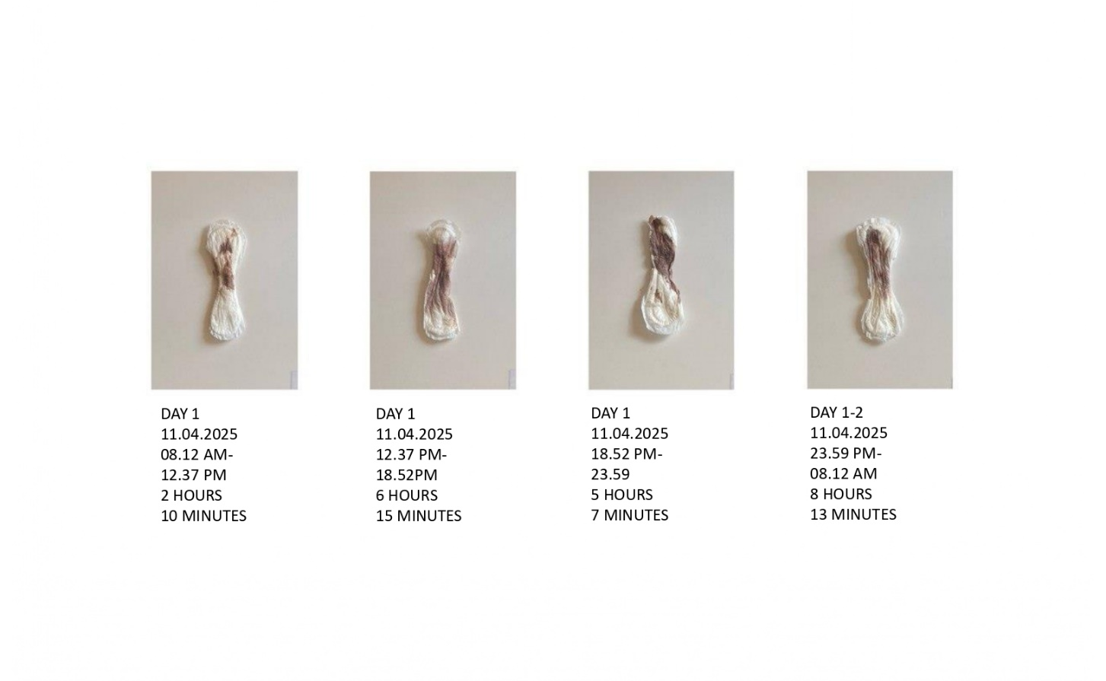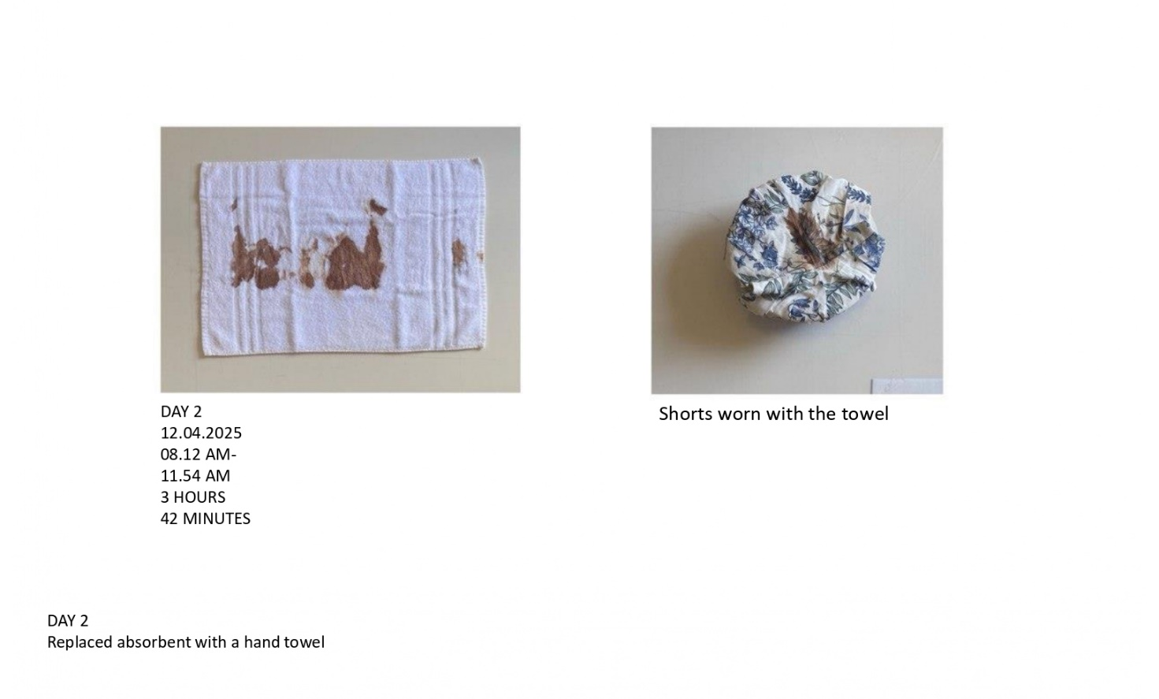
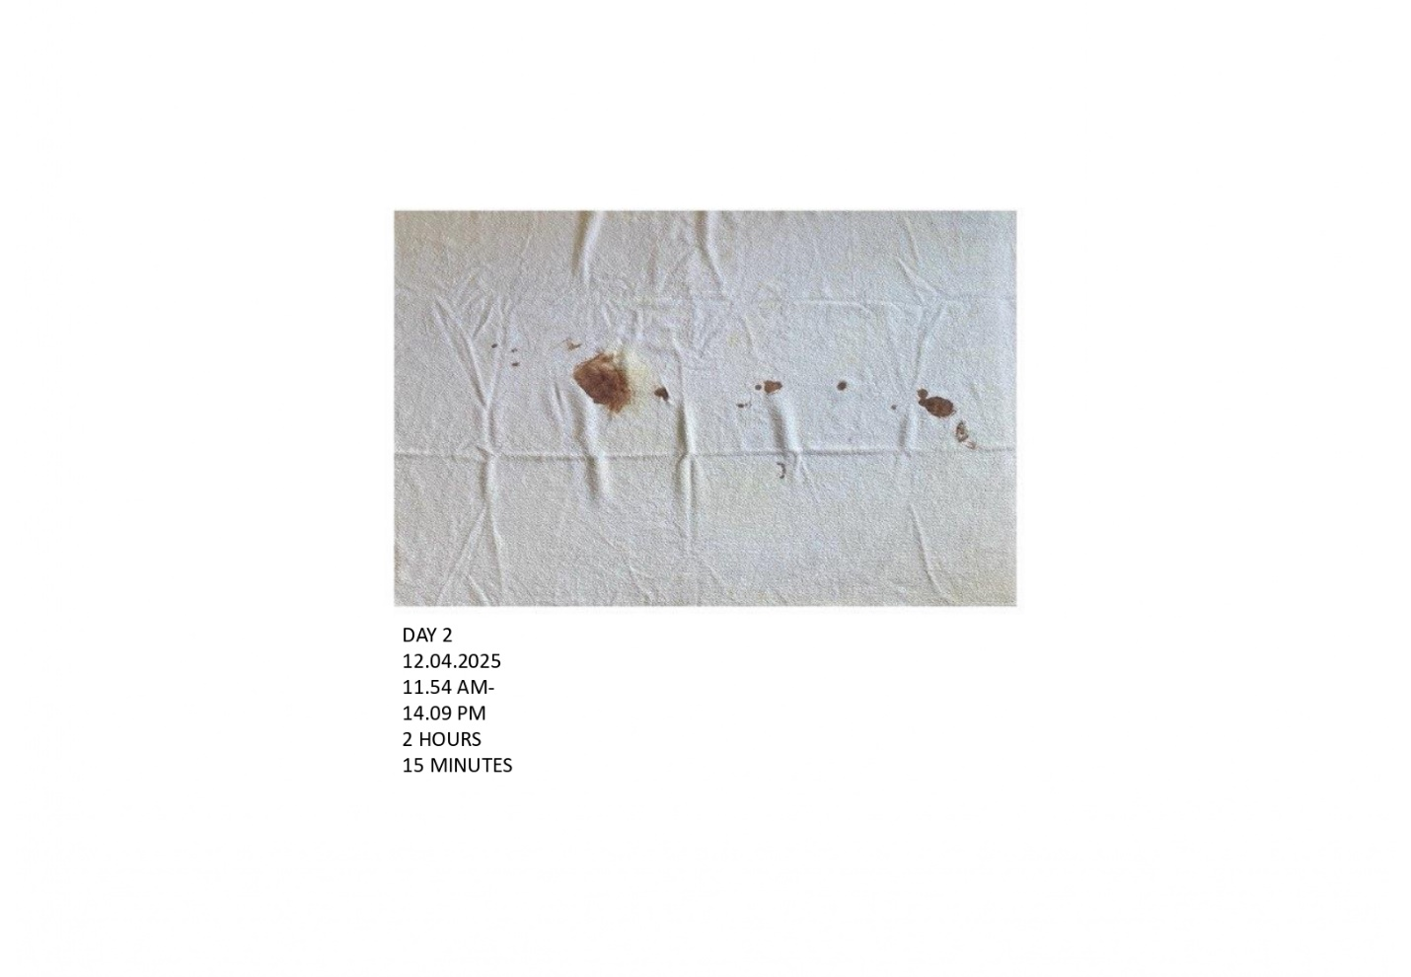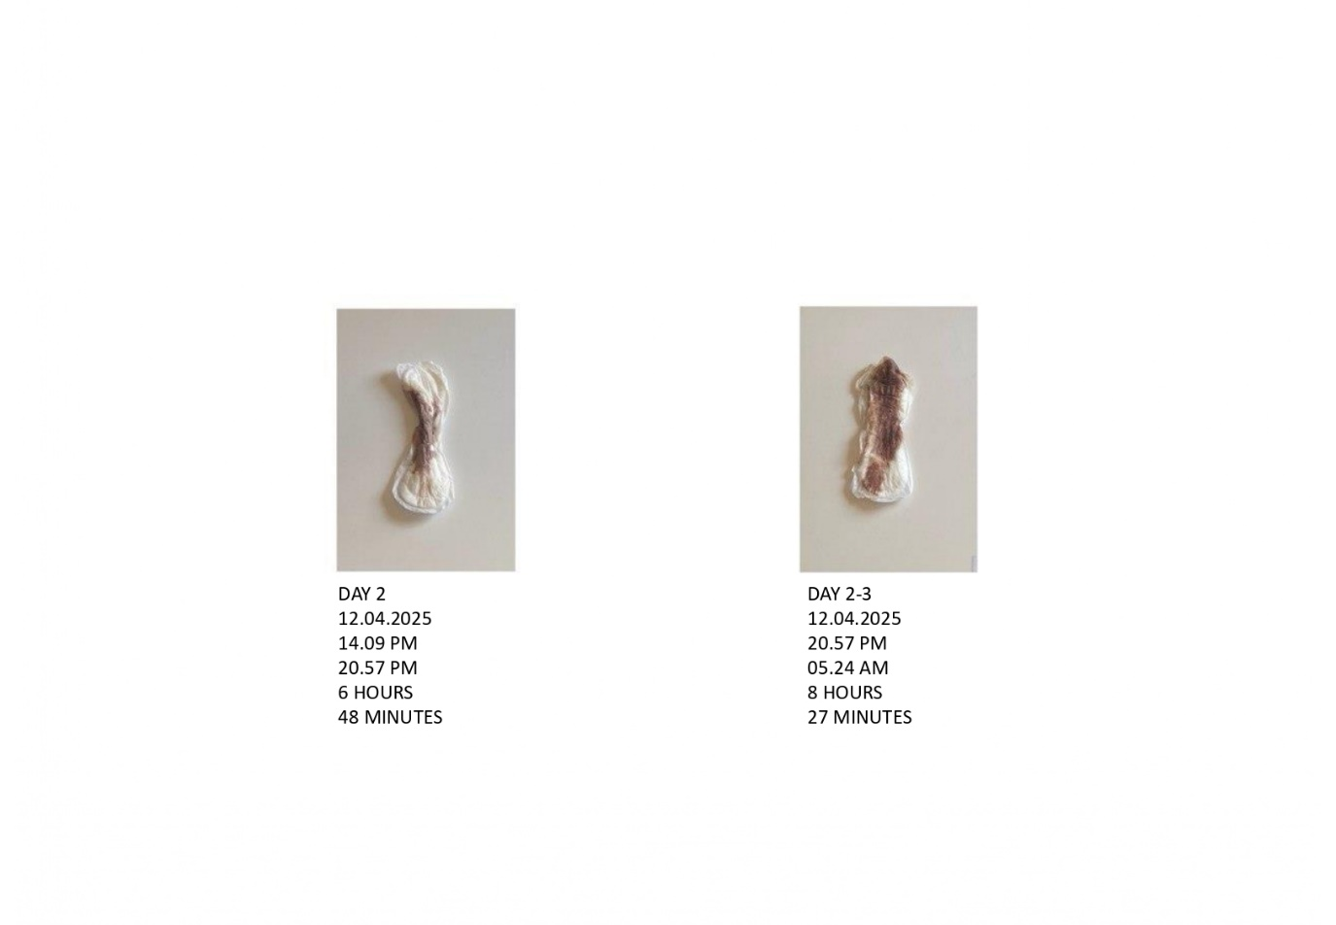
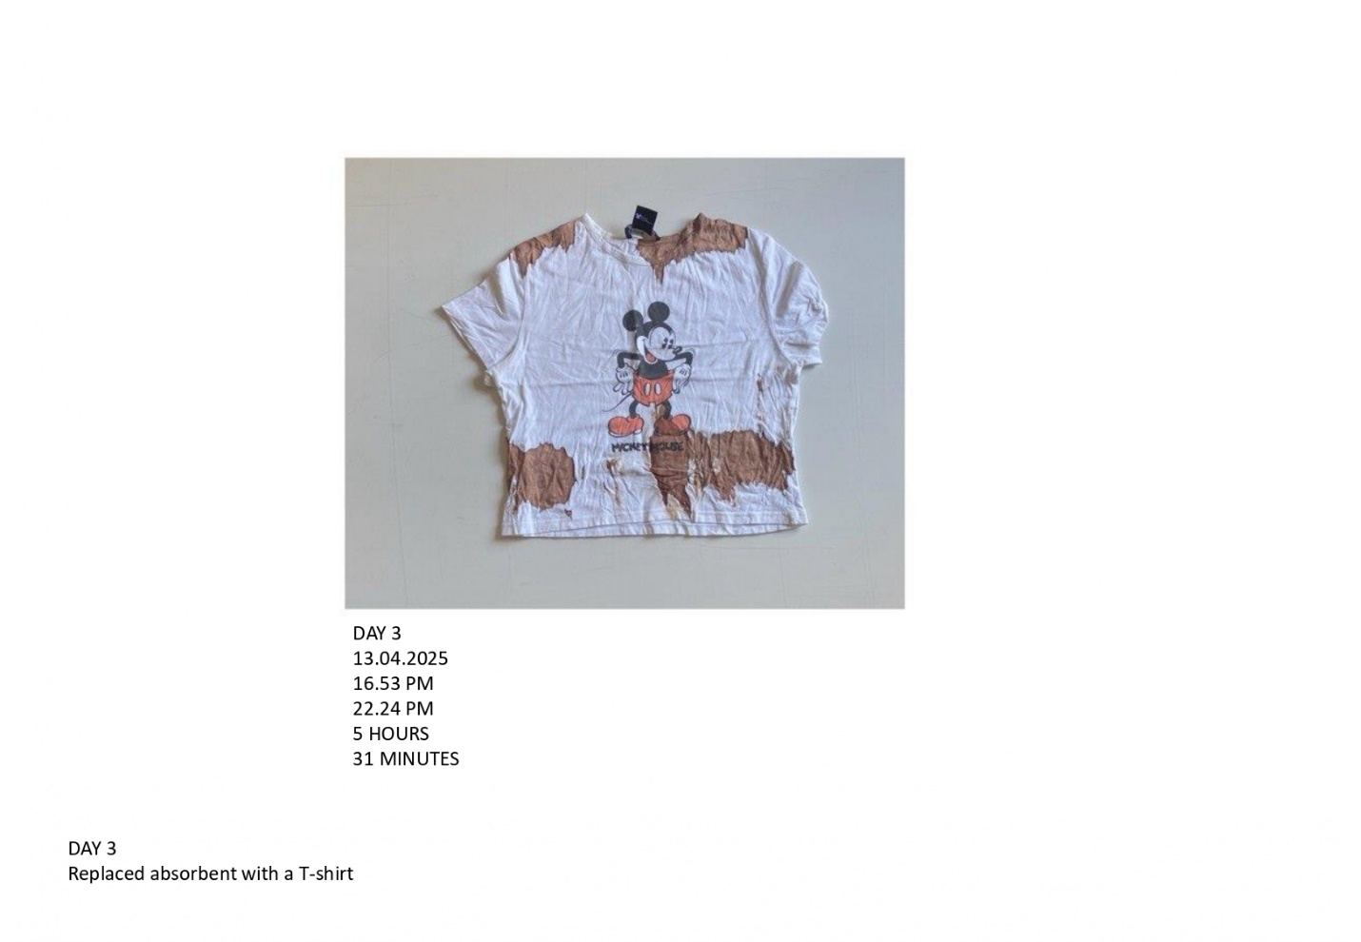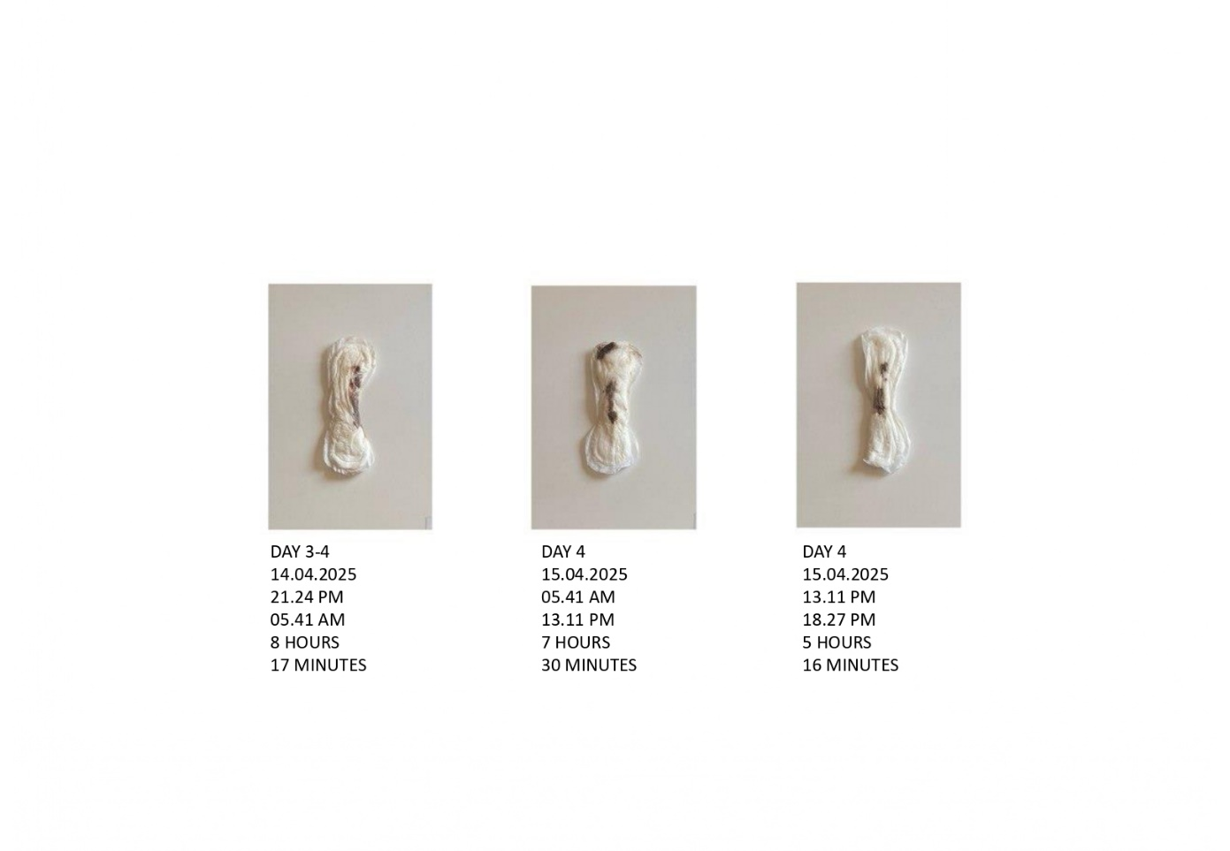
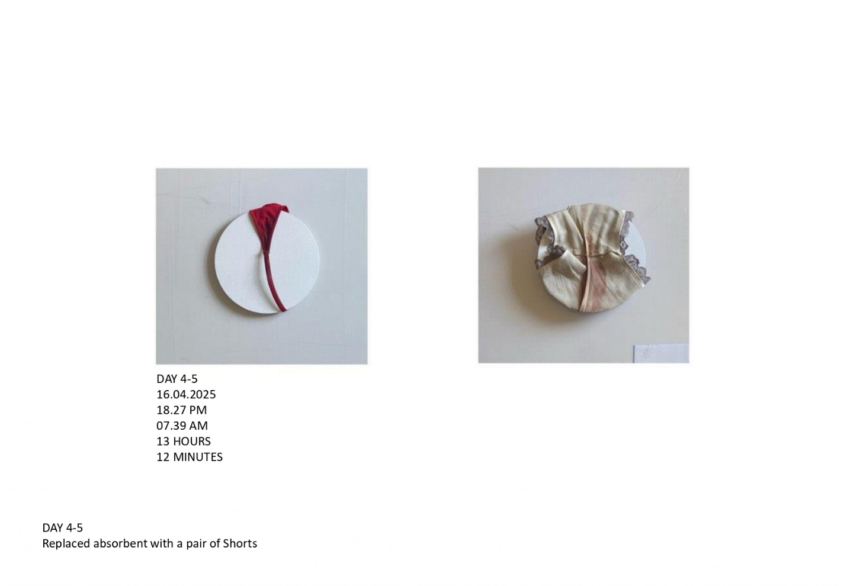
The Body as Archive is a series produced over the course of a single menstrual cycle, documented not through language or narrative but through objects placed in direct contact with the bleeding body. Pads, towels, improvised absorbents, and a Mickey Mouse T-shirt—referencing the sanitized Disney aesthetics of menstruation education—become material records of bodily time. Each object carries the trace of a specific moment: variations in flow, pain, substitution, endurance, and survival. Rather than functioning as disposable waste, these materials operate as evidence, transforming the private management of menstruation into a visible archive of lived experience.
This work conceptualizes the menstruating body itself as an archival site. The archive here is not static or institutional, but organic and temporal. It stores memory through saturation, rhythm through repetition, and affect through residue. Menstrual blood, absorbed into fabric, records hormonal fluctuation, physical discomfort, emotional vulnerability, and inherited rituals of concealment. By elevating these objects into the space of art, The Body as Archive challenges the cultural logic that frames menstrual materials as something to be immediately discarded and forgotten. Instead, the work insists that these traces constitute a continuous, living history—one that has been systematically excluded from visual and cultural memory.
The choice of materials is central to the work’s conceptual force. Menstrual pads and towels are designed to erase evidence, to restore the illusion of bodily control and social normalcy. In this series, that logic is reversed. The domestic becomes monumental, and what is meant to disappear is preserved. The visible accumulation of blood resists the expectation that menstruation should remain discreet, minimal, and barely perceptible. The archive thus exposes a discrepancy between cultural assumptions about menstruation and its material reality.
Audience reactions to the work underscore the persistence of menstrual stigma, particularly along gendered lines. When the series was shown informally to approximately ten male acquaintances, the dominant response was shock at the quantity of blood. Several expressed discomfort, describing the material as “gross,” and most avoided approaching the works closely once informed that the blood was real, despite being dry and odorless. This reaction reveals how deeply menstrual blood is coded as contaminating, even when stripped of sensory threat. The hesitation to look closely suggests that the stigma surrounding menstruation operates less at the level of hygiene and more at the level of symbolic anxiety and learned aversion.
In contrast, the response from women revealed a different but equally telling form of internalized stigma. Five close female friends initially agreed to document their own menstrual cycles as part of a collective extension of the project, framing it as a shared social practice. However, all ultimately refused to submit their materials, citing embarrassment and discomfort. This withdrawal is significant: it illustrates how menstrual shame is not only externally imposed but also internally regulated. Even in a supportive, feminist context, the fear of exposure proved difficult to overcome. The refusal itself becomes part of the archive—an absence that speaks to the limits of visibility and the power of inherited silence.
The Body as Archive thus functions on multiple levels: as a personal documentation, a material critique of disposability, and a social experiment that exposes entrenched attitudes toward menstrual visibility. The work demonstrates that while menstruation is universally experienced, its representation remains fraught with resistance, discomfort, and denial. By insisting on preservation rather than erasure, the project reframes menstrual blood not as excess or waste, but as testimony—evidence of a body that remembers what culture repeatedly tries to forget.

6. Conclusion
This thesis has examined menstruation as a bodily process that is at once biologically ordinary and culturally fraught, shaped by long-standing regimes of stigma, concealment, and regulation. Through an interdisciplinary engagement with feminist theory, queer scholarship, visual culture, and artistic practice, it has argued that menstruation functions as a critical site through which gendered power relations are both enforced and contested. Rather than treating menstrual stigma as a residue of outdated beliefs, this research has demonstrated that it remains actively reproduced through cultural norms, commercial practices, media representation, and social interaction.
Drawing on theoretical frameworks of stigma (Goffman, 1963), abjection (Kristeva, 1982), purity and pollution (Douglas, 1966), and performativity (Butler, 1988), the thesis has shown how menstruation becomes socially legible only through its concealment. The menstruating body is expected to appear controlled, discreet, and uninterrupted, aligning with dominant ideals of femininity that privilege coherence, cleanliness, and emotional composure. These expectations operate not only at the level of representation but are materially enforced through technologies of hygiene, fashion norms, medical intervention, and capitalist infrastructures that frame menstruation as a problem to be managed or suppressed. Such systems reveal menstruation to be a biopolitical concern—regulated through both external surveillance and internalized self-discipline.
At the same time, this research has argued that menstruation is not merely a site of regulation but also a site of resistance. Menstrual art, across archival practices, performance, photography, and media intervention, disrupts the cultural demand for invisibility by insisting on presence, duration, and materiality. By preserving menstrual traces, staging bleeding bodies, or allowing leakage to appear within everyday and pleasurable scenes, artists challenge the assumption that menstruation must be hidden in order for bodies to remain socially acceptable. These practices do not aim to sanitize menstruation or render it universally comfortable; rather, they expose the discomfort itself as culturally produced and politically meaningful.
A central contribution of this thesis lies in its emphasis on visibility as an epistemic act. Menstrual art does not simply represent menstruation; it produces knowledge about how bodies are disciplined, how shame is learned, and how norms are maintained through silence. Audience responses—ranging from shock and avoidance to embarrassment and withdrawal—demonstrate that menstrual stigma operates affectively as much as ideologically. The difficulty of looking, touching, or participating reveals how deeply the menstrual body remains coded as threatening, even in progressive or feminist contexts. These reactions underscore the limits of formal equality or surface-level normalization and point instead to the need for sustained cultural interrogation.
By integrating art as practice into the analytical framework, this thesis has foregrounded embodied knowledge as a legitimate mode of inquiry. The artworks developed as part of this project do not function as illustrations of theory but as sites where theory is tested, complicated, and sometimes resisted. Through material engagement with menstrual products, blood, and bodily time, the practice challenges the disposability and erasure that govern menstrual management. In doing so, it positions the menstruating body as an archive—one that records memory, endurance, and affect outside institutional forms of documentation. This approach contributes to feminist methodologies that recognize vulnerability, reflexivity, and situated experience as sources of critical insight rather than methodological weakness.
Importantly, this research situates menstruation beyond a cisnormative framework. By engaging queer and trans scholarship, it challenges the persistent assumption that menstruation is synonymous with womanhood, highlighting how gender-diverse menstruators often experience intensified stigma due to the misalignment between bodily function and social recognition. Menstrual art and activism that decouple menstruation from fixed gender identities expand the political possibilities of visibility, reframing menstruation as a shared bodily process rather than a marker of normative femininity.
In addressing the research question—how menstrual art can challenge historical and sociocultural stigma in contemporary visual culture—this thesis concludes that such practices operate not by resolving stigma but by exposing its mechanisms. Menstrual art does not offer comfort or closure; it offers confrontation, endurance, and insistence. By refusing erasure and embracing material presence, it unsettles the cultural fantasies that rely on the disappearance of menstrual bodies. In this sense, menstrual art functions as both critique and proposition: a critique of systems that demand bodily silence, and a proposition for new ways of seeing, inhabiting, and acknowledging the realities of embodied life.
Ultimately, this thesis argues that cultural change around menstruation requires more than visibility alone—it requires sustained engagement with discomfort, contradiction, and resistance. Menstrual art, in its refusal to be discreet, polite, or easily assimilated, insists that the body be encountered on its own terms. In doing so, it opens space for a more honest, inclusive, and politically attentive understanding of menstruation—not as a problem to be managed, but as a lived reality that demands recognition.

6.2 Future Perspectives
The research and practice presented in this thesis open multiple avenues for future exploration, both within artistic practice and broader cultural engagement with menstruation. While this project has foregrounded the material, visual, and experiential dimensions of menstruation, there remains significant potential to expand inquiry into intersectional, global, and technological contexts. Future work could further investigate how menstruation is experienced across different cultures, socioeconomic conditions, and geographic regions, highlighting how stigma and visibility are unevenly distributed and negotiated. Such research could foster a more inclusive understanding of menstruation as a lived reality that transcends Western-centric frameworks and recognizes diverse bodily, cultural, and gendered experiences.
From a creative perspective, future projects might explore alternative materials, scales, and formats to continue challenging the boundaries of menstrual representation. This could include immersive installation, virtual reality, interactive digital media, or collaborative participatory art that invites audiences to engage physically, emotionally, or relationally with menstrual experience. The potential of interdisciplinary collaborations—combining art, design, science, and technology—offers new ways to interrogate the social, biological, and affective dimensions of menstruation while expanding the reach and impact of menstrual visibility.
The ongoing digital landscape presents both opportunities and challenges. Social media and online platforms remain potent sites for menstrual activism, yet they are simultaneously structured by content moderation, algorithmic bias, and commercial imperatives that often reproduce stigma. Future research could critically engage with these infrastructures, exploring how digital technologies shape the visibility, reception, and cultural meaning of menstruation. Projects might investigate alternative platforms or decentralized networks that allow for uncensored, community-driven documentation and dissemination of menstrual experience, amplifying voices that are frequently marginalized or silenced.
Finally, there is significant scope for the continued integration of practice-led research with feminist, queer, and trans-inclusive frameworks. Artistic practice can remain a site of experimentation, reflexivity, and resistance, producing knowledge that challenges normative assumptions about gender, embodiment, and bodily temporality. By emphasizing endurance, materiality, and vulnerability, future work can continue to interrogate the social, political, and affective structures that govern menstruation, while imagining new possibilities for visibility, agency, and collective care.
In sum, the future of menstrual representation lies not only in visibility but in the cultivation of spaces—artistic, social, and digital—where menstruation can be acknowledged, explored, and understood as a complex, multifaceted aspect of human experience. Such work promises to extend the insights of this thesis, fostering cultural, ethical, and political engagement that is attentive to both the realities of the body and the possibilities of collective imagination.

REFERENCES
- Ahmed, L. (1992). Women and gender in Islam: Historical roots of a modern debate. Yale University Press.
- BBC. (2008). Menstruate with pride [Art performance]. BBC Arts.
- Bobel, C. (2010). New blood: Third-wave feminism and the politics of menstruation. Rutgers University Press.
- Bobel, C. (2019). The managed body: Developing a feminist analysis of menstrual practices in contemporary media. Feminist Media Studies, 19(2), 135–151.
- Bobel, C., Winkler, I. T., Fahs, B., Hasson, K. A., Kissling, E. A., & Roberts, T.-A. (Eds.). (2020). The Palgrave Handbook of Critical Menstruation Studies. Palgrave Macmillan.
- Brumberg, J. J. (1998). The body project: An intimate history of American girls. Vintage Books.
- Butler, J. (1988). Performative acts and gender constitution: An essay in phenomenology and feminist theory. Theatre Journal, 40(4), 519–531.
- Butler, J. (1990). Gender trouble: Feminism and the subversion of identity (2nd ed.). Routledge.
- Chrisler, J. C., Gorman, J. A., Manion, J., & Farley, E. (2016). Menstruation and gender identity: Experiences of masculine-of-center and transgender individuals. Psychology of Women Quarterly, 40(1), 1–13.
- Clark, J. (2014). Menstruation [Artwork]. In Exhibition Catalogue.
- Douglas, M. (1966). Purity and danger: An analysis of concepts of pollution and taboo. Routledge.
- Elwes, C. (1979). Menstruation I & II [Performance & installation].
- Fahs, B. (2016). Out for blood: Essays on menstruation and resistance. State University of New York Press. menstruationresearch.org
- Frank, S. E. (2020). Queering menstruation: Transgender men, non-binary individuals, and the cultural politics of bleeding. Gender & Society, 34(1), 3–18.
- Foucault, M. (1977). Discipline and punish: The birth of the prison (A. Sheridan, Trans.). Pantheon Books.
- Goffman, E. (1963). Stigma: Notes on the management of spoiled identity. Prentice-Hall.
- Green-Cole, S. (2019). Frida Kahlo and the politics of bodily suffering. Journal of Visual Culture, 18(2), 145–163.
- Halberstam, J. (2005). In a queer time and place: Transgender bodies, subcultural lives. New York University Press.
- Johnston-Robledo, I., & Chrisler, J. C. (2020). Menstrual health: Transforming taboo into pedagogy. Sex Roles, 82(9), 579–595.
- Jones, A., & Warr, T. (2012). The feminist imagination: Artistic interventions in the body and sexuality. Routledge.
- Kristeva, J. (1982). Powers of horror: An essay on abjection (L. Roudiez, Trans.). Columbia University Press.
- Lorde, A. (1984). Sister outsider: Essays and speeches. Crossing Press.
- Maple, S. (2010). Menstruate with pride [Artwork].
- Mendieta, A. (1974). Body Tracks [Performance & photography].
- Moussaoui, D., Smith, K., & Torres, R. (2023). Menstrual suppression in transgender adolescents: Gender affirmation and psychosocial outcomes. Journal of Adolescent Health, 72(3), 421–430.
- Owen, J. (2022). The medicalization of menstruation and the culture of concealment. Women’s Studies International Forum, 92, 35–46.
- Plan International. (2020). Breaking the barriers: Menstrual health and hygiene in low-income countries. Plan International.
- Roberts, T., Goldenberg, J., & Smith, K. (2002). Social stigma and menstrual concealment: Perceptions and consequences. Journal of Social Psychology, 142(3), 341–353.
- Rostvik, K. (2019). Bleeding as resistance: Menstrual art in the 20th and 21st centuries. Routledge.
- Schneemann, C. (1972). Blood Work Diary [Diary & performance].
- Schneemann, C. (1975). Interior Scroll [Performance].
- Schut, M. (2022). The (R)evolution of the menstrual cycle: The spiritual and queer perspectives of the menstrual movement in conversation (Master’s thesis, MA Gender Studies, Utrecht University).
- Stiles, K. (1993). Performance, body, and the politics of abstraction: Kubota and women in Fluxus. Art Journal, 52(1), 78–90.
- Thomas, A. A. (2021). Queering menstrual taboos: Dirt, disorder, and transformative potential. Feminist Theory, 22(1), 10–15.
- Tonelli Manica, L., & Rios, J. (2017). Bleeding bodies: Performance, menstruation, and feminist art. Routledge.
- Tiegs, V. (2000–2006). Menstrala [Series of paintings].
- UNICEF. (2020). Menstrual hygiene management in schools: Global report. UNICEF.
- Vostral, S. (2008). Under wraps: Menstrual technologies and media. Rutgers University Press.
- Weiss-Wolf, J. (2017). Periods gone public: Taking a stand for menstrual equity. Arcade Publishing.
- Wood, J. (2020). Menstrual concealment, hygiene, and the neoliberal mandate. Feminist Studies, 46(2), 318–337.

